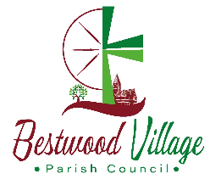
Bestwood Village
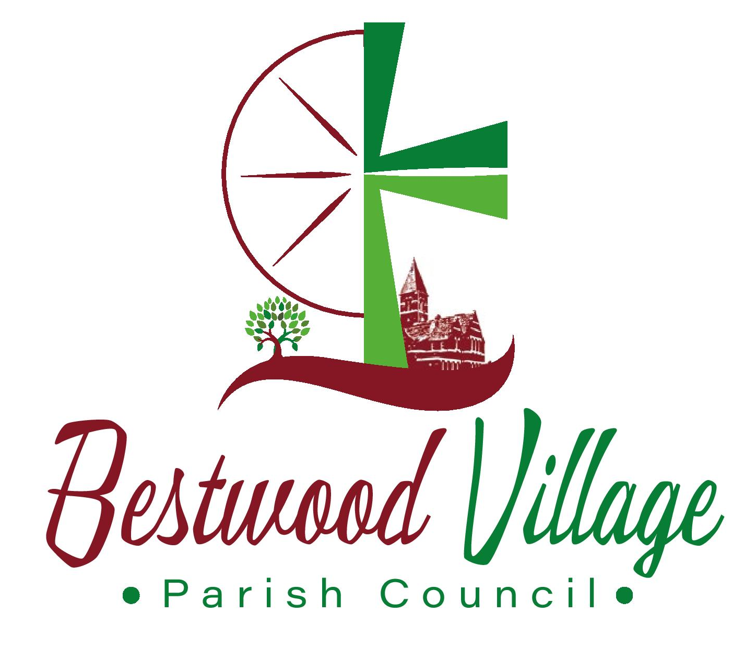
Parish Council
Date: Tuesday 13th June 2023 at 7pm
At St Mark’s Church Bestwood Village

Ahead of this meeting All Councillors will have signed their Acceptance of Office forms and will receive copies of the Code of Conduct and be made aware of the need for the completion of their Declaration of Members interests forms for Gedling BC.

You are summoned to attend the ANNUAL FULL COUNCIL meeting to be held for the purpose of transacting the business on the agenda below.

Issued on 4th June 2023 by Susan Stack (CiLCA)
Locum Clerk to the Council
clerk@bestwoodvillagepc.org

AGENDA

1 | Silence to remember those that have passed
2 | To receive apologies for absence
3 | To Elect a Chairman for 2023/24 year (who will sign the Declaration of Office)
4 | To elect a Vice Chairman for 2023/24 year
5 | To consider and resolve on application(s) to be co-opted onto the Parish Council
7 | To receive and consider - Declarations of members’ interests and dispensations from non-participation
8 | To receive and approve the minutes of the Council meeting held on 2nd May 2023
9 | To receive and note - Any update on actions arising from previous Parish Council decisions (not included elsewhere on the agenda)
10 | To receive reports from  - County Councillor  - Borough Councillors  - Parish Councillors
11 | To receive - Parishioners questions/statements (normal duration 15 minutes)
12 | To resolve that all new Councillors be added to the Bank Mandate to view and authorise transactions
13 | To delegate authority to two or more Councillors in agreement to respond/spend on behalf of the Council as follows;  - Responding to District Council on residential planning applications  - Authorising repairs to Council equipment (eg playgrounds) up to a maximum of £250 per item between meetings  - Purchasing and reclaiming costs of plants for Council planters up to a maximum of £100 per occasion  - Instructing the Lengthsman to carry out work on behalf of the Council  - Maintaining the notice boards with agenda and other statutory items
14 | To approve payments for the month (as e-mailed to Councillors to pay)
  Susan Stack | 180.00 | Clerks Salary May
  HMRC | 45.00 | Tax
  Susan Stack | 9.05 | Mileage & printing May
  Susan Stack | 180.00 | Clerks Salary June
  HMRC | 45.00 | Tax
  Susan Stack | 9.05 | Mileage & printing June
  Countrywide Grounds Maint | 93.64 | Parks Maintenance
  Ian Hart | 5.98 | Flowers *assuming receipt received
  Ian Hart | 34.10 | Flowers *assuming receipt received
15 | To discuss – Appointment of an internal auditor for 2023/24 year
16 | To discuss – Request for works to be undertaken on the Square
17 | To discuss – Councillor’s e-mail addresses
18 | To receive reports and discuss;  - Environment working group Report  - Lengthsman Scheme update  - S106 Monies – Projects & Consultation.  - Planning applications review  - Update on traffic issues  - Storage room for Council property  - Playground inspections and repair  - Christmas lights, invoice dispute  - Community events
19 | To discuss – Arrangements for seeking a permanent Clerk and RFO
20 | To agree the date and time of the next meeting (Tuesday 11th July 2023)

