Sydling War Dead
WW2

Four men of Sydling died in WW2 Here are two of their stories.

William Thomas Fox

William was born in Sydling, in 1916. His father was a road mender for Cerne RDC. William joined the Royal Navy at the start of the war, and married Lilly Card, a Bristol girl, in October 1940. They had no children,
He served as a first class stoker on the HMS Hecla. In 1941 she was based at Havelfjord, Iceland, as the mother ship for destroyers escorting the Atlantic convoys, which would anchor alongside her for repairs. Churchill and Roosevelt visited the ship on their way home after signing the Atlantic Charter.

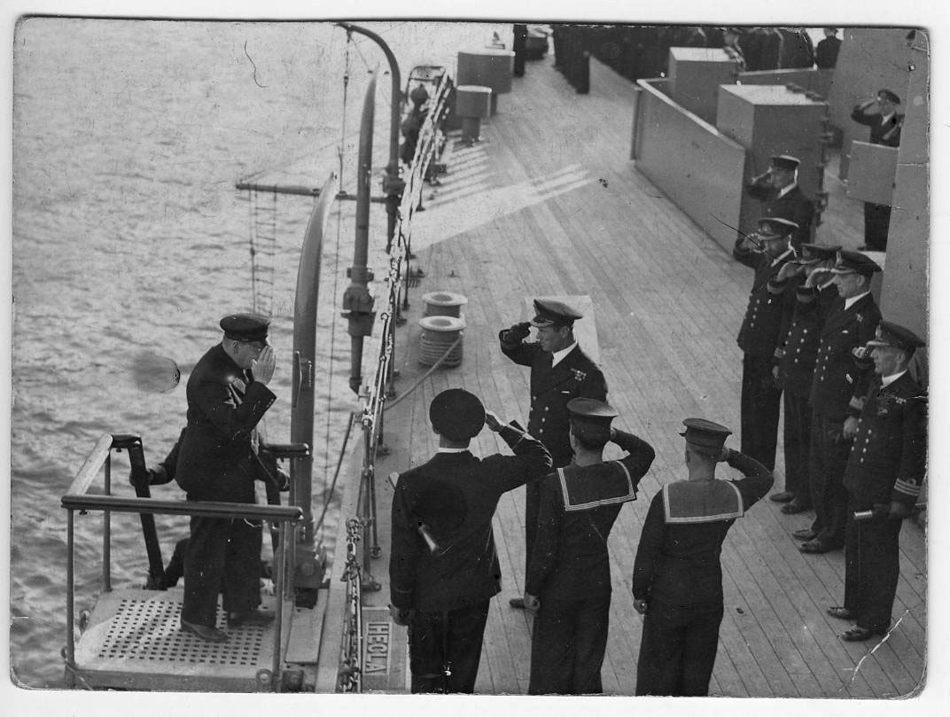

Then, after a refit in the Clyde, HMS Hecla headed south, to help defend Singapore against the Japanese, but off the coast of South Africa, she detonated a mine. She sustained significant damage, and 20 men died. She managed to limp into Simonstown, and was then under repair for 5 months. Perhaps the crew were able to enjoy these months, the last opportunity for many who would never make it home.
On October 20th 1942, Hecla left Capetown, with HMS Vindictive, and headed towards Gibraltar, to support the ships taking troops to the Invasion of North Africa. The ship was off the coast of Casablanca, when it was torpedoed 5 times by a U boat.
William was 26 years old. 273 men lost their lives that night, there were 858 survivors. Whose stories can be seen here
http://www.holywellhousepublishing.co.uk/survivors.html

His brother Norman, 3 years older than him, was a farm labourer in 1939. He lived to the age of 77 and is buried in Sydling churchyard

Robert Charles Webber

Robert was born in Bridport 1902. In 1930 he married Mary Kathleen Hansford, whose father was a cowman for Hawkins at UpSydling farm.

There had been Webbers at Up Sydling before: in WW1 19 year old Gunner W Webber of the Royal Field Artillery, son of William and Mary Webber of Up Sydling farmhouse, died at sea, in Thessalonika. Robert was only 6 years younger than him. Perhaps they were cousins, and perhaps that is how he came to know Mary?

Robert joined the Royal Navy in about 1924. He was an able seaman and served on several ships. In 1937 he moved to HMS Glorious.
He was 5ft 9 inches tall, with dark hair, brown eyes and a fresh complexion.
On 9th June 1940 he was 37 years old when HMS Glorious was lost to enemy action in icy Norwegian waters. He was reported as missing, presumed dead.
HMS Glorious was an aircraft carrier, taking part in the evacuation of British troops from Norway. She was escorted by 2 destroyers. She was torpedoed and sunk, leaving 900 men in the sea, of whom only 40 survived the 3 days until they were found by Norwegian vessels. The link below tells the harrowing story in more detail

https://www.historytoday.com/hms-glorious-history-controversy

