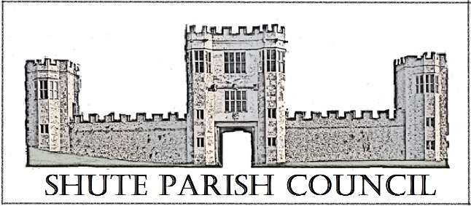

Colhayne Close, Colhayne Lane, Shute nr Axminster Devon, EX13 7QQ
Parish Clerk - Carol Miltenburg
tel:- 01404 831080 e mail:- clerk@shute.eastdevon.gov.uk

The Councillors were summoned to attend a meeting Shute Parish Council held at the Umborne Hall on Thursday January 25th, 2018 starting at 7.30pm.

Those present were Cllrs Paddy Magrane, Bill Marshall, Richard Orsman, John Pearce, David Plowman, Peter Rugg (Chairman), Rick Wood. Cllr Ian Chubb (EDDC & DCC). Carol Miltenburg (Parish Clerk). One member of the public Angela Parry.

The following matters were discussed. Cllr Marshall, vice Chairman, welcomed everyone present on behalf of Cllr Rugg.

- Apologies for absence were received from Cllr Sweetland. No declarations of interests were made.

- The minutes of the meeting of December 7th, 2017 were approved by the Council and signed by Cllr Marshall.

- Matters arising from previous minutes. Dog poo bin – the order has now been placed. A map showing the approximate location has to be sent to EDDC. Cllr Orsman will speak with Derek Loud, the land owner to discuss the exact location and has agreed to accept delivery. He and some of the other Councillors will erect it. Phone Kiosk, no response has been received from Mr Hammond so it was agreed to send an e mail stating that the kiosk will be removed shortly. Commonland at Shute Hill - The Commonland Commissioner is based at DCC, they have been contacted and a reply is awaited. Salt Bin – the Clerk confirmed she has written to Ms Kelly & Mr Nicholds and is waiting for a reply.

- Public Forum. Angela Parry commented on the repairs to the pot holes at Seaton Junction and said how well they had been done. The Clerk will pass on the comments to DCC Highways.

- Finance. Payments to be made C Miltenburg £734.87 - Clerks salary & expenses; Came & Co £280.00 -Hitchcock Trust insurance (50% to be reclaimed from Kilmington PC, invoice 002/2018); Mr R Wareham £260.00 - Burial Ground maintenance for 2017. Payments received – Western Power £26.74 – wayleave; J Clarke & Son £680.00 – interment of ashes, Mr Tuck. The Council approved the payments Cllrs Magrane and Wood proposed and seconded.

Parishes Together Fund projects. Applications have to be in by early February. Three options were discussed. Cllr Chubb mentioned the speed sign project with Dalwood since our expression of interest no information has been received. Clerk to contact Dalwood PC. Cllr Marshall spoke on the Air Ambulance landing site with Axmouth, Musbury and other PC’s. The location of the site is at Axmouth football ground but this was felt unlikely to benefit Whitford as there are nearer sites and it would not benefit the Shute end of the parish. The third project was equipment for the Road Warden with Widworthy. It was agreed that the speed camera was of most interest and if that is not possible the equipment for the road warden project. Clerk to liaise.

- Reports from Parish, District & County Councillors and Police. There were no reports by the Parish councillors or Police. Cllr Chubb gave a report on EDDC – The planning permission for Pegasus to redevelop the Knowle has been granted. The Exmouth office is now open and the Honiton office being built with the aim of moving in December 2018. Recycling is continuing to rise and is now 61%. There have been problems with litter but a modification is being made to the vehicles to stop this. A collection of garden waste is likely to be introduced for a charge of £40 or so a year. The budget have been set for the next financial year with a small increase. There is now an app which links to EDDC.
His report on DCC. He has been very busy with 20 or so parishes to look after. The main issues in the Blackdowns seem to be roads and broadband. Scanska have now taken over the contact for road repairs and there have been good reports to date.

- Burial Ground update. Burial book – the Clerk circulated examples of the pages to the Council. It was agreed that the changes required can be agreed by e mail. The Clerk is to write to the Church concerning the wall adjacent to the Burial Ground and the repairs that are needed. It was agreed that if the Church would give permission for the Council to make the repairs, this would allow it to be made into a memorial wall and would produce a revenue stream for the Council. Cllr Marshall will contact Kevin Coombes of Colyford to obtain a quote. It was agreed to have a site meeting (when it is drier) of the Council with Linda Marshall, Roy Wareham and the builder to decide on planting, maintenance, designation of a scattering area and renovation of the wall.

- Car Park. The update was given by Cllr Plowman. He outlined the discussions with DCC who originally would not support a car park on the front playground. He asked Cllr Chubb for his help and backing of our case with DCC. He advised that the school was continuing with obtaining a lease on part of the field behind the school to use as a sports field and nature area. As this is now in the control of the school the Committee will not meet again until the lease is obtained.

- Planning –
18/0124/LBC - Bakers Cottage, Shute, EX13 7PU. No objections.
17/2992/FUL – Starbucks – car park lighting (retrospective). No objections, but felt the lights should be turned off when the outlet is not open.

- Highway Matters. Flooding etc. Cllr Marshall showed the Council photos of the recent flooding in Whitford in Hampton Lane and by the village hall. The pipes under the lane by Hampton Court had become blocked by gravel. The Clerk has requested DCC Highways to clear them as soon as possible. The pedestrian bridge at one point was under water. The chief engineer for EDDC Dave Turnan could give residents advice on reinforcing the stream bank. The Clerk reported on the contact with DCC Highways concerning Ashes Lane (debris), Lyme Bay Cider (potholes), Lodge Lane (flooding), Hampton Lane (blocked culverts) etc

- Correspondence received. Healthwatch Voice magazine.

- Any Other Business. The meeting calendar for the next year was given out to the council and approved. Cllr Magrane advised that there will be a meeting at St Michael’s church, Shute to discuss its future. He has been to visit the church at Eype and this may become a suitable model for Shute.

Date, time & place of next meeting:- Thursday, March 8th starting at 7.30pm at Shute School.

The meeting ended at 9.15pm

