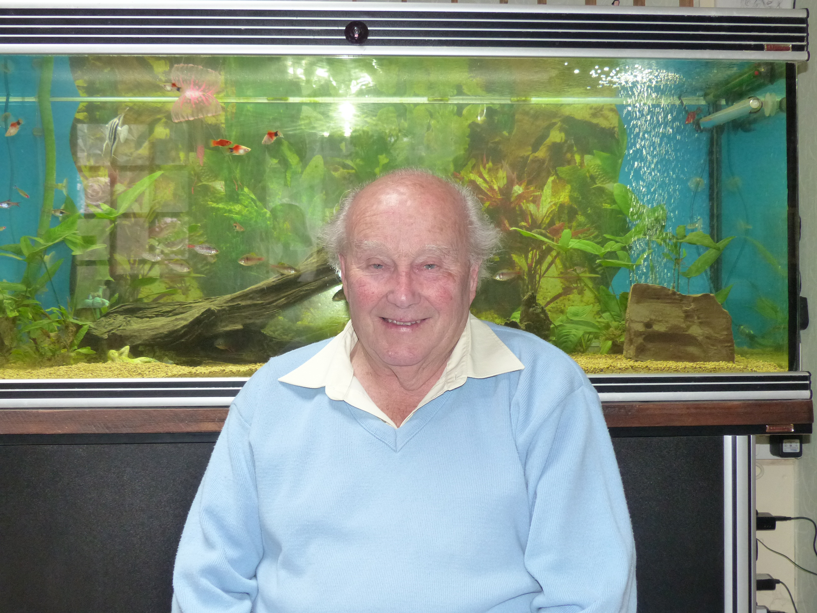
Howell Roger

Index number: MWOH002011

Recorded on: Wednesday 18th May 2016 by Anne Weaver and Roger Davis
Time commenced: 10.45 Duration: 32 minutes Location: Afton Cottage, Adlers Lane, Westhumble.

Roger was born in Stratford on the edge of London in 1932 and then lived in Rainham, Essex until he was eighteen. He starts by telling us that, during the war years, he would occasionally queue at the grocers or doctors, saving a place until his Gran or Aunt took his place. His father grew vegetables and also kept hens, and we hear how Roger made chocolate spread when the jam ran out. Public transport was used to get most of the shopping, although they would walk to the village shop for the odd item. Once home the food was stored in a kitchen cabinet, on a stone slab or in the case of meat, in an outside cupboard. Pasteurised milk was delivered weekly and the ginger beer and Tizer man called every other week. Roger’s Gran did all of the cooking, and his favourite meal was on a Sunday when meat was usually served. Lack of money meant that they did not eat out. His father was in the fire service during the war, working 48hour shifts and Roger and his Gran would stay with his Uncle, Aunt and three Cousins in their rented farmhouse. It was in the orchard here that they would often have picnics. Returning to when he queued for groceries Roger tells us what sort of things they bought including dried eggs and margarine that may have come from whale oil. He tells us that they kept over a hundred chickens & that the eggs were shared with friends & neighbours, but that they didn’t eat the chickens. Some of the vegetables grown, including marrows, brussel sprouts, lettuces, and potatoes were taken to a butcher’s shop nearer London to be sold. We hear that although frightening, Roger also found wartime exciting, with tales of near misses from doodlebugs flying overhead, and of decoy fires lit in the marshes to divert the German planes. Returning to his time spent in the farmhouse we are told who the occupants were and that staying there meant that Roger had to attend two schools. Rather than school dinners he would usually take sandwiches but he would be given milk, cod liver oil and malt. Roger tells us about a banana, brought home by his Uncle John, which was cut up and shared between four. During the war years Roger’s Father used his carpentry skills repairing planes at Biggin Hill, this included going up in the air with the test pilots, which was often frightening. When Roger was 18 he and his family moved to Huntingdonshire, where his father had become an estate manager responsible for the repairs on twelve farms. Part of this job was to take the doors and windows from cottages prior to a valley being flooded. During a holiday in Worthing he met his future wife’s parents and he wrote to their daughter for six months before meeting her.
Later Roger moved to North Berwick, Scotland, where a house was prepared by joining two cottages, and then after six months, he married Rhona. We hear a little about the marriage and reception, which was followed by a honeymoon in Arbroath. Roger then returned to work on a large estate consisting of three farms and he tells us about his work including the potato crop, a beef herd, seasonal turkeys, tractor driving and fencing. In 1966 Roger, together with his family, moved to work for Mr Compton, Westhumble where he stayed until 1985. This new job involved Chapel Farm, Bradley Farm and Ranmore Farm and Roger tells about the management of each, the crops grown and the type of livestock kept. By this time he had a daughter and a son, both of who went to Ranmore School, often taken there by Sheila Compton, before they moved to senior schools in Dorking. Roger estimates that he worked ninety hours a week depending on the seasonal work at the farm and he describes the yearly cycle of sowing, making silage, the harvest followed by more ploughing ready for the winter. During the winter months his time was spent on farm maintenance. Holidays to Boscombe were taken at the beginning of July and Rhona’s father, who was now a widower, joined them. Finally we hear of picnics taken after the war setting off from his Uncle’s post office in Nutbourne, using an Austin Seven van carrying nine passengers to Chanc tonbury Ring.

