**Ampfield Parish Council**

**Kate Orange, Clerk to the Council**

**2 The Square, Braishfield Road,**

**Braishfield**

**ROMSEY SO51 0PQ**

**🕿07922 118840**

**clerk@ampfield.org.uk**

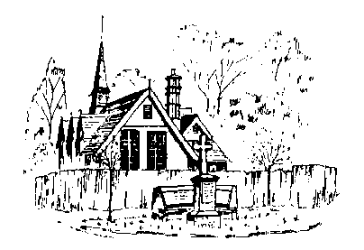

dd mmmmmm 2020

To nnnn