Halam WI
September Newsletter
Hello everyone,
Socially Distanced get-together
It was lovely to see everyone who came to The Milkshed last month. Thank you to Olive and her family for letting us use the space, we couldn’t have asked for a more picturesque setting.
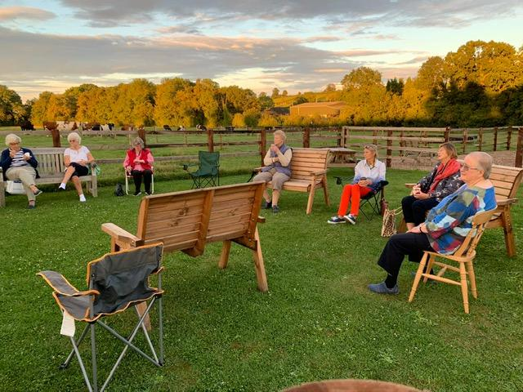
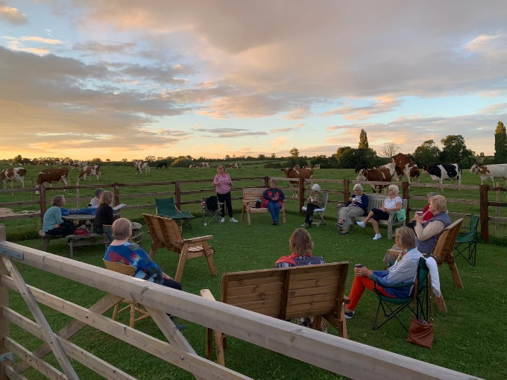

WI Diaries
If you would like to order a WI diary for 2021 please let me know by 1/10/20. They are £5.90 each or if we can send an order for 10 they will be £5.60.

50/50 club
If anyone is interested in the 50/50 club, please contact me for an application form. Closing date is 30/10/2020

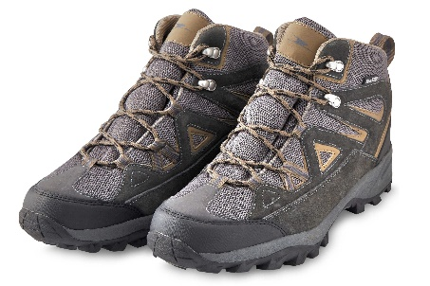Rita’s Walk in Southwell
- Start at the Leisure Centre. Cross the road and walk up the footpath (at the side of Tudor building).
- At the end of the footpath turn right (fence on left of Lowes Wong School). Follow the path round and end up at the top of The Ropewalk.
- Go down The Ropewalk and across Market Place and down The Burgage.
- Cross over and go down Station Road. Opposite the Final Whistle pick up the footpath and walk alongside the river Greet to the Main Road.
- Turn right by the garage and keep to that footpath and turn left towards Southwell garden centre.
- By the South Well turn right down the track to the gate and cross the field to Farthingate. Turn left and follow round.
- Turn right and on left hand side you will see a footpath sign between two houses which takes you into a field.
- See bridge opposite, go over the footpath will take you to the park. At the side of the football club and cemetery gates pick up the footpath which takes you back to Minster school and Leisure Centre.

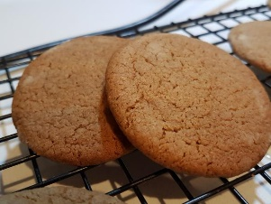
Olive’s Ginger Biscuits
Ingredients
4oz butter
4oz caster sugar
4oz self-raising flour
2 level teaspoons of ground ginger
Method
Put everything into a food processor and blitz until it forms a dough. Roll into balls the size of large marbles. Cook on ungreased baking tray well spaced out until brown, about 15-20mins at 150-160oc. Allow to cool on trays.

Stay safe and keep well.
Sara

