BANK STATEMENTS AS AT 9 SEPT 2020

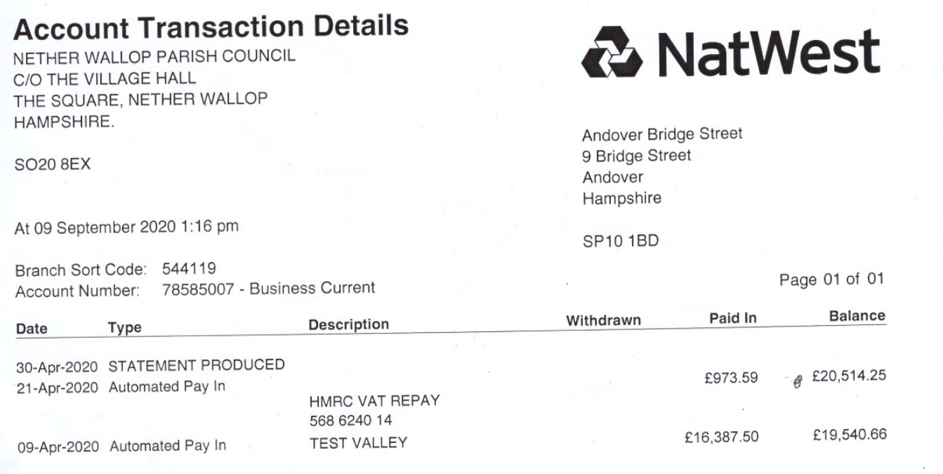

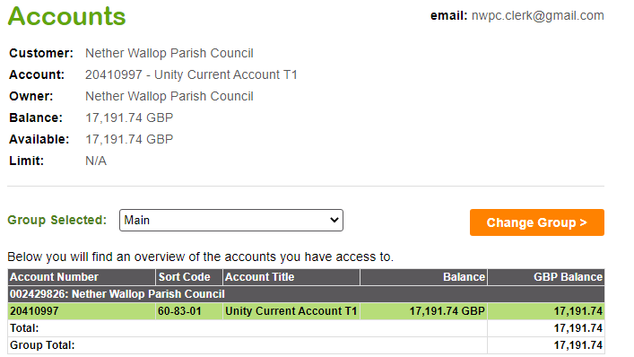

TOTAL HELD IN BANKS: 20,514.25
17,191.74
--------------
£ 37,705.99

