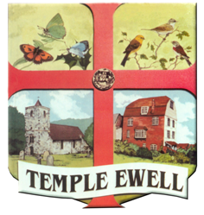
TEMPLE EWELL PARISH COUNCIL
SOCIAL MEDIA POLICY

1. This policy applies to all members and employees of the Parish Council.
2. Social media includes the Parish Council website, Facebook and Twitter accounts.
- This policy applies in work hours and out of work hours, on personal equipment and equipment owned by the council.
- The Parish Council encourages the addition of posts on the website & Facebook and tweets as a way to raise awareness of issues that are or may be relevant to parishioners and those interested in the village.
- Members and staff that have their own personal social media profile(s) must ensure that any comments regarding the council, its members, or staff are made in a way that does not negatively portray them. Members and staff must not post disparaging or defamatory statements about the council or its stakeholders; they should make it clear in social media postings that they are speaking on their own behalf (unless they are posting as part of their job role).
- Members and staff must not post comments about sensitive community topics, such as planning applications.
- If members see content on social media that disparages or reflects poorly on the council, they should refer this to the Clerk or Chair of the council.
- Members and staff must not post anything that could be considered discriminatory against, or bullying or harassment of, an individual. Most councils will stipulate that these rules apply as much to personal social media as they do to the council’s accounts.
- Personal use of social media is not permitted on council owned equipment.
- Members and staff contacted by the press or social media outlet for comment should refer to the council’s policy for dealing the Press/Media.
- These rules apply as much to personal social media as they do to the council’s accounts.
- Any breach of the policy may lead to action being taken under the council’s disciplinary policy.

Version 1.0 Updated 4/5/2020

