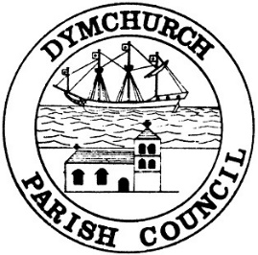
Members of Assets and Amenities Committee of Dymchurch Parish Council are summoned to a meeting to be held on Wednesday 21st July 2021 at 7.00pm At the Parish Council Office, Orgarswick Avenue.
Agenda
- APOLOGIES

- DECLARATIONS OF INTEREST
- To declare any personal interests in items on the agenda and their nature.
- To declare any prejudicial interests in items on the agenda – any councillors with prejudicial interests must leave the room for the relevant items.

- ELECTION OF COMMITTEE CHAIR
Members to elect a new chair for the Assets and Amenities committee.

- MINUTES OF THE PREVIOUS MEETING
The previous meeting minutes of the Assets and Amenities Group held on 16th March 2021 to be agreed and signed as a true record.

- MEMORIAL BENCHES
Members to discuss current arrangements for memorial benches, pending requests and future policy.

- UPDATE ON ONGOING PROJECTS
Update on Blooming Dymchurch, landscaping, seawall trading licences/kiosks, flagpoles & village signage.

- FESTIVE LIGHTS
Members to discuss requirements for 2021 Christmas lights prior to the full Council meeting in September.

- QUEENS JUBILEE BEACON LIGHTING
Members to discuss refurbishing the seawall beacon.

- RECREATION GROUND PLAYGROUND
Members to review correspondence received from F&HDC regarding replacement equipment for the recreation ground.

- ANY ITEMS FOR FUTURE AGENDAS

- DATE OF NEXT MEETING:
The date of the next meeting will be Tuesday 21st September 2021 at 7.00pm

Adrian Lawson
15th July 2021
Projects & Finance to Dymchurch Parish Council

