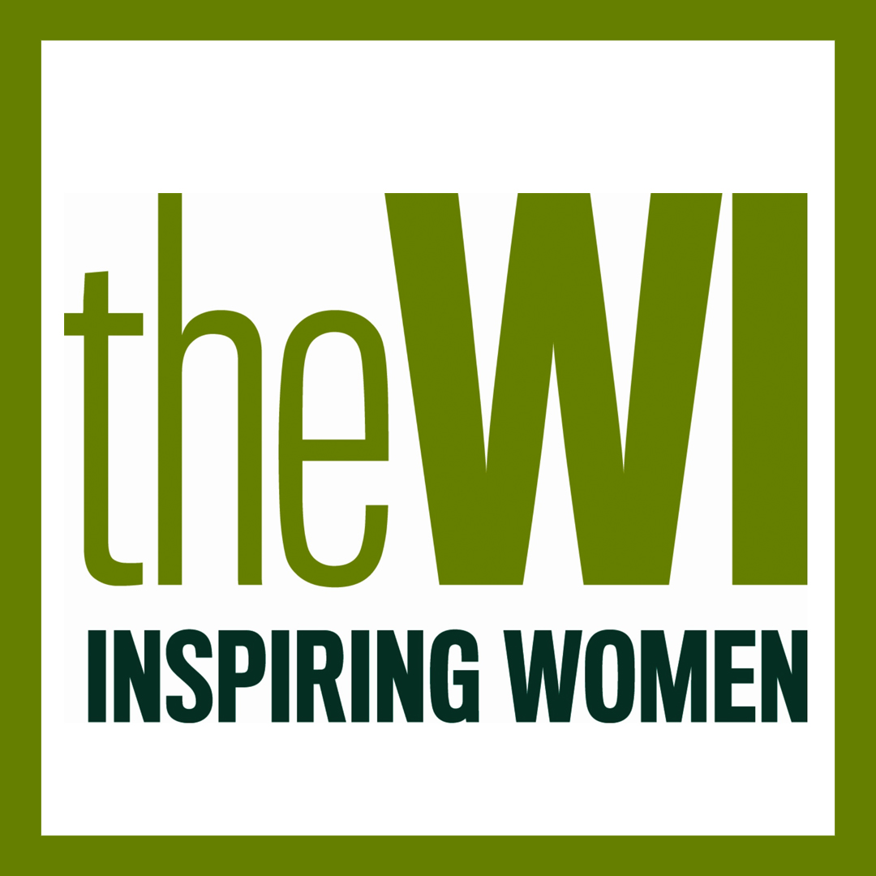

Halam WI
March 2021 Newsletter
Hello everyone,
I hope everyone is keeping well. With the news last week of the Government’s roadmap out of lockdown the Committee and I have been making plans for the reopening of Halam WI. We really hope you can join us on Tuesday 8th June 2021 at the Milkshed, Radley Road for a belated Halam WI birthday gathering. There will be cake and like last time you’ll be able to either bring a drink or purchase one from the Shed.

Subscriptions
You may have already read in February’s WI magazine that NFWI have been concerned about the difficulties created by Covid-19 and its impact on WIs and members. They have therefore decided that there will be greater flexibility allowing WIs to decide how much to charge for their portion of the membership subscription.
This year the annual subscription is £44 and is broken down as follows:
£12.10 goes to NFWI, £10.30 goes to Nottinghamshire Federation and £21.60 stays in Halam WI funds. The Committee have decided that for this year our existing funds is sufficient to allow us to waiver the Halam portion of the subscription. Your fee this year (April 2021-April 2022) will therefore be £22.40.
Subscriptions are due 1st April 2021. As we are not meeting, could you please post a cheque payable to Halam and District WI to Katie Bowling, Willow House, School Lane, Halam, NG22 8AD.

Programme for the rest of the year
I am currently organising speakers and activities for the rest of this year as I am very hopeful that we will be able to meet up in the village hall from July. I will pass on a full list in April’s newsletter.

Facebook
Last Friday evening Katie and I joined a Zoom meeting run by the new Communications team at County House. This has made us consider how we communicate with Halam WI members and anyone who is interested in our WI. Katie is in the process of updating our Facebook page to make it more accessible and informative for current and potential new members.

Annual Federation Meeting
Would anyone like to be Halam WI’s delegate for the Annual Federation Meeting on Thursday 22nd April at 7pm via Zoom? Please let me know and I’ll forward your details.

Competition
We thought it would be a good idea if Halam WI had their own logo to use on our Facebook page, on posters or even on our own badges like Nottingham City WI have had made. If you would like to have a go at designing a logo for us to use, please either post or email your design to me by Friday 30th April. I have added some examples of other Nottinghamshire WI logos below.

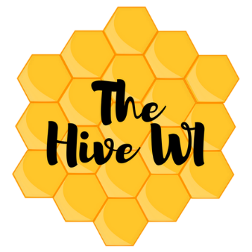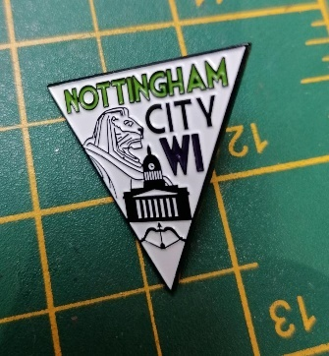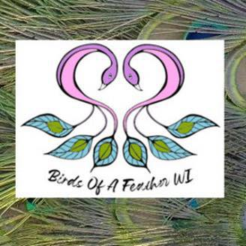

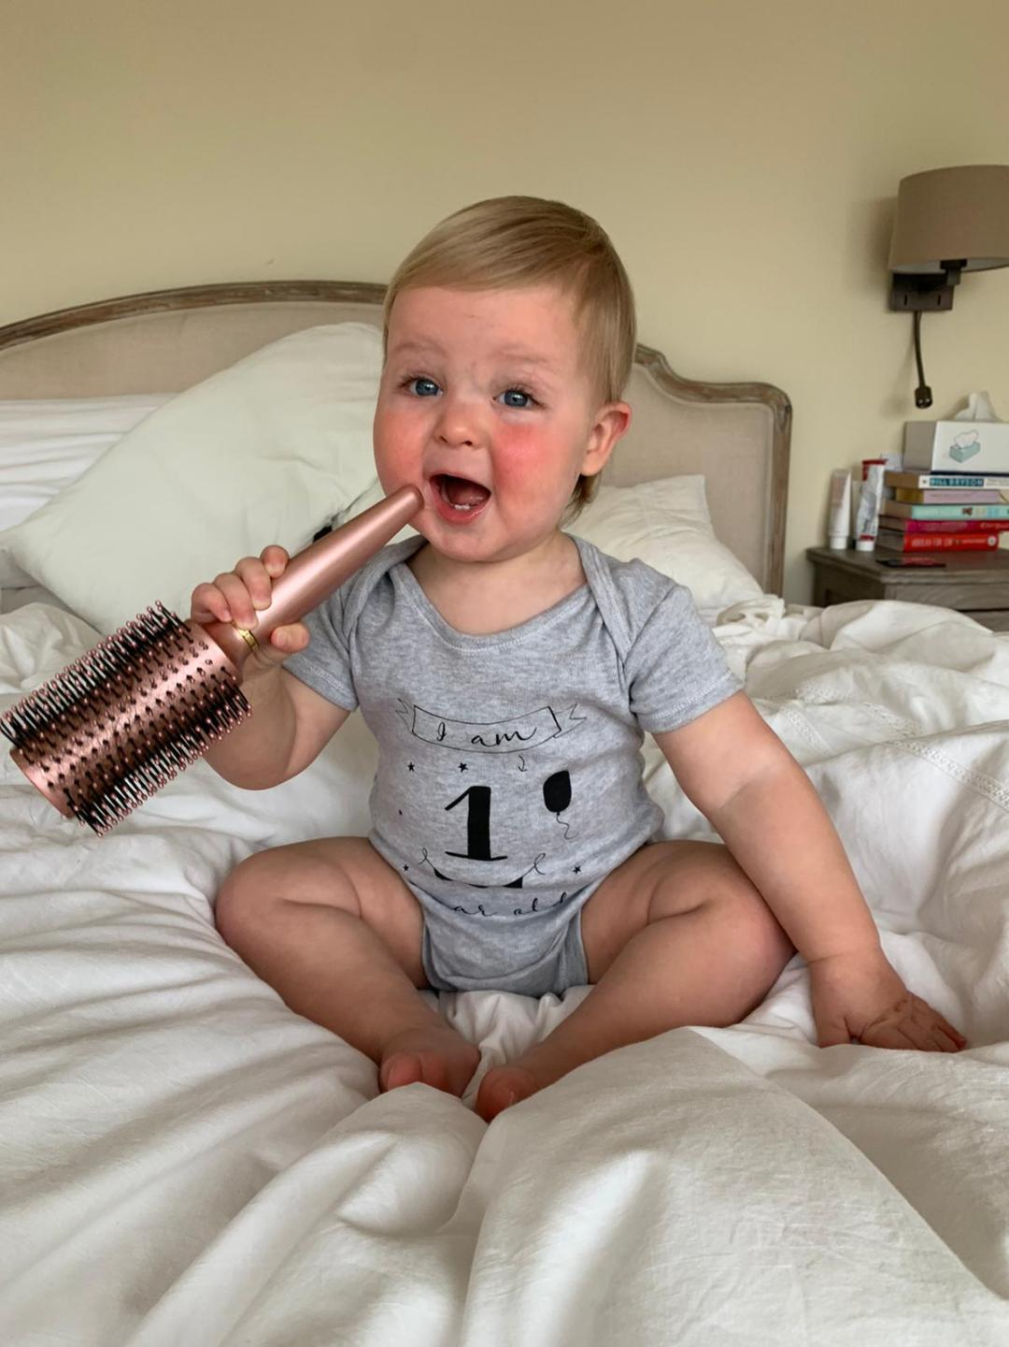

Happy Birthday to Teddy Bowling who turned 1 last month.

Sara Subramanian - President

