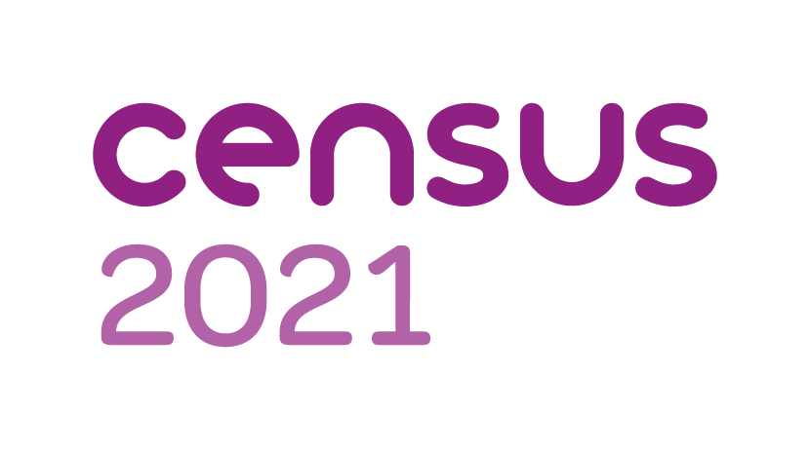
Census Support in Shropshire
- If you require support to complete the census you can share your access code with family and trusted friends who can complete the census on your behalf.
- During week commencing 8th March: every household will receive an information pack that includes your access code

Online Completion
Complete the census online using your access code. Online help is available at https://census.gov.uk/ including a Web Chat facility.The online census is compatible with Assistive technology for screen readers & magnifying technology

Telephone support
The National Contact Centre Helpline 0800 141 2021 provides 3 options:
- Option 1: automated service to request a paper form using your access code
- Option 2: listen to the answers of Frequently Asked Questions
- Option 3: speak to an adviser

- You can complete the census with a Telephone Capture service where you answers will be completed by an adviser
- Ring 0800 587 2021 to use a translation service featuring 53 languages ( the census can only be completed in English or Welsh
- There is a Text Relay service at 18001 0800 141 2021
- You can order a large print census form from the Contact Centre

Shropshire Library Service Census Support Centres
Unfortunately due to Covid 19 it is not currently possible to visit the centres but they will provide telephone help, telephone completion and Microsoft Teams meetings to help people complete the census. Ring these libraries for local help:
Shrewsbury: 01743 255308
Oswestry: 01743 250351
Ludlow: 01743 250010
Whitchurch: 01948 662238
Market Drayton: 01630 652105
Bridgnorth: 01746 76335

