PETROCKSTOWE PARISH COUNCIL
Parish Clerk: Fiona Lowe, Rose Farm, Petrockstowe, Okehampton EX20 3HQ
Phone: 01837 811749 E-mail: petroc.clerk@hotmail.com

Dear Councillors
You are duly summoned to attend the Petrockstowe Parish Council Meeting to be held at 8pm on Tuesday 26th July 2016, at Baxter Hall, Petrockstowe, to discuss the following business.

AGENDA

- Apologies of Absence. To receive any apologies

- Declarations of interest

- Public Session

- Minutes. To consider the approval of the minutes of the Annual General Meeting of 17th May 2016, having been previously supplied.

- Planning. Planning applications since 18th May 2016.

- Councillors Reports for information.
- Recreation Ground – Cllr Kelsey
- Play Area – Cllr Jeffs
- Baxter Hall – Cllr Harris
- County / District – Cllrs Boyd / Wiseman
- Police Report – PSCO Baxter

- Matters arising from previous minutes.
- Clay Lorries driving through the village – update Clerk
- War Memorial – update Clerk
- Website – update Clerk
- Queen’s 90th Birthday Medals – Update Cllr J Harris

- Current Business.
- Planning Meeting of 19th May – update Cllr Fisher
- Basic Council documents required – Clerk
- Recreation Ground Insurance – Cllr Kelsey

- Financial Items
- Precept Payments
- Payment to TK Play
- VAT reclaim; cheques for Rec Grd and Play Area
- Internal Audit Invoice
- Clerks expenses
- Laptop Antivirus protection – expense to be approved
- Annual membership of ICO

- Confirm date of next meeting.

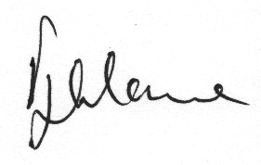

Fiona Lowe
Parish Clerk
20/07/2016

