As we move towards the end of 2020 there is now more hope and optimism that an end to the pandemic is in sight. We have a clearer idea of how Christmas can be celebrated and families briefly reunited, there are vaccines on the horizon and mass testing becoming a reality. But the virus is still there and we must continue to be vigilant and follow all the guidelines – let’s all keep ourselves and others safe.
A newsletter from the Borough Councillors of the Mid-Test Ward
Mid-Test Matters
Issue 18 1December 2020

Coronavirus updates

Test Valley Cases

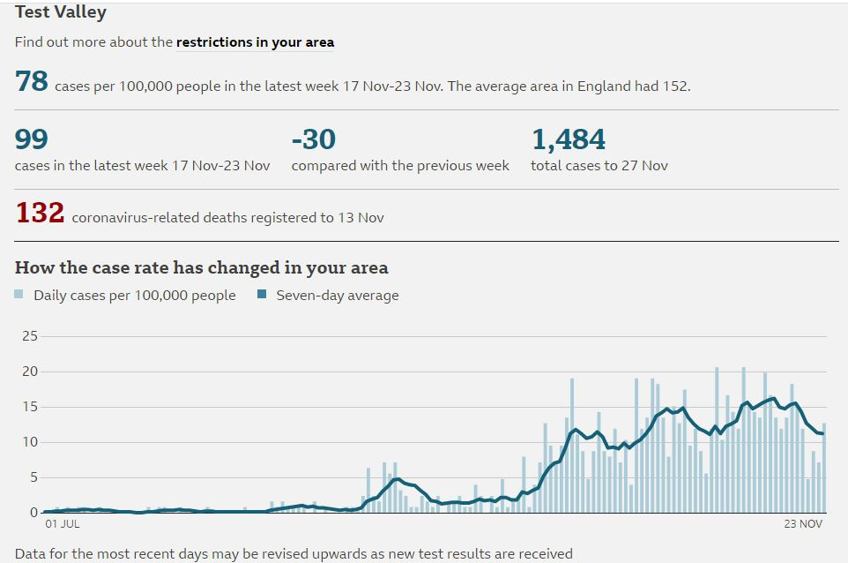
COVID-19 Mental Health and Wellbeing
Coronavirus (COVID-19) is having an impact on everyone’s daily lives, as the government takes necessary steps to manage the outbreak, reduce transmission and treat those who need medical attention. During this time, you may be bored, frustrated or lonely. You may also feel low, worried, anxious, or be concerned about your health or that of those close to you. These are all common reactions to the difficult situation we face. Everyone reacts differently to events and changes in the way that we think, feel, and behave and this will vary between different people and over time. It’s important that you take care of your mind as well as your body. See the links below for practical steps which may help maintain positive mental health and well-being during the pandemic.
COVID-19: guidance for the public on mental health and wellbeing
COVID-19: guidance on supporting children and young people’s mental health and wellbeing

Free Phone Lines for Support Groups
Many support groups have been created across Mid-Test to provide fantastic support to the vulnerable members of our community who need it most. The group established in Mottisfont have established a phone number for residents to call should they need anything, and have kindly shared some useful information that may be of interest. The company that provides the phone number also gives access to a web-based control panel through which you can set up a schedule of people that the number will divert to when called. The company providing this service is TTNC Ltd, when they heard what the phone line was being used for they waived all charges.
Please find a link to the company’s website: https://blog.ttnc.co.uk/ttnc-business-as-usual-during-the-lockdown/, the section ‘How we can Help’ provides more information

Covid-19 Grants
A number of Community Foundations and other organisations have launched funding programmes to assist local organisations in responding to the challenges of the Coronavirus Pandemic. The website ‘Grants Online’ is regularly updated with new funding opportunities: https://www.grantsonline.org.uk/coronavirus.html

Christmas Food Boxes
With the Christmas holiday break fast approaching and uncertainty around jobs and finances for lots of families and individuals across the borough, Organisations and Agencies across the Valley have come together to support those in the most need.
These organisations and agencies, including Romsey Community School (RCS) would like to offer Christmas Hampers to those living in food poverty and to those older people in our community who could do with a boost this Christmas. They would like to deliver a surprise hamper of small gifts to be opened daily along with cards and pictures from local school children to show them that they are being thought of this year.
Particularly focussing on those families and individuals who are above the limit for support from benefits and those experiencing financial hardships. The food boxes will be advertised via social media and people can self-refer to the deliveries.
In order to do this, referrals are needed to ensure they reach the people who need them most. This can be done using a referral form which has been created. A link to this form is attached below, but if you have any difficulties opening this please contact Imogen Colley, (details below) who can send you a copy. There is an initial deadline of the 4th December but that does not mean you cannot refer people after this date.
The Christmas Hamper contains:
- Treat hamper of Christmas goodies – provided by Food Banks – Andover – early December/Romsey with delivery
- Ingredients and recipes for 5 main meals including fresh fruit and vegetables
- Creative resource pack for families to do together
- Books/board games
- Card/Picture/message from local school children in each parcel.
- Support leaflets from; Foodbank, Community Pantry, Mind, CAB etc., leaflet offering assistance with managing health, wealth and other issues.
For more information, or if you would like to be sent a copy of the referral form please contact icolley@testvalley.gov.uk / 01264 368958
Other Borough News
Dormice at Finkley Down Farm!
It’s great that despite the pandemic the Council still strives to support even the smallest of our residents. Finkley Down Farm have been working with the countryside team in Community and Leisure carrying out a Dormouse survey in their hedgerows.They have been using footprint tunnels to determine presence or absence. These work by containing a mixture of Oil and Charcoal Powder acting as ink and a strip of paper. The dormice then walk over these and tread the ink across the paper leaving footprints behind.
Finkley Down Farm have been undertaking this survey for 6 weeks so far and in there last check they found Dormice! Dormice are a rare and protected species in the UK, making this find even more exciting.
We will continue to work with Finkley Down Farm using the footprint tunnels in the hope of finding more clear footprints and the next step will be to install nesting boxes to enable ongoing surveys.

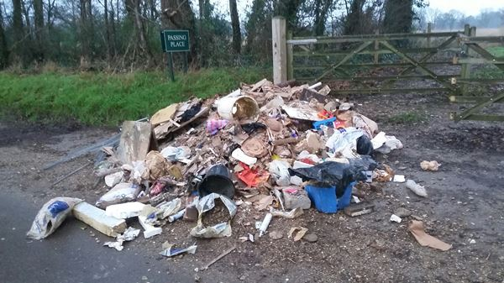
Frauds & Scams
It is a sad fact that some people pray on peoples' trust and good nature, with fraudsters coming up with new and believable scams all the time, so it is important that we protect ourselves and others from their insidious actions.
To help us all know how to recognise scams, how to avoid them, and what to do if we get targeted, the Office of Police & Crime Commissioner and Hants Constabulary have put together a pack of information on the most common types of fraud. The pack has been designed specifically for vulnerable members of our communities and focuses on common signs of scams and simple steps that promote confidence and independence.
The pack is available here: www.hampshire-pcc.gov.uk/safe-from-fraud and can be viewed online or downloaded and printed and shared so that anyone - relatives, neighbours, friends and professionals can help to spread the message about avoiding scams.
There is also a useful site with up to date information on current scams available through Hants/IOW Alert: https://www.hampshirealert.co.uk or http://www.iowalert.co.uk which anyone can sign up to in order to help keep us alert and stop the fraudsters.
Successful prosecutions
A man has been prosecuted after a using another person’s vehicle which led to the fly-tipping of a huge amount of waste following a house renovation.

Just before Christmas in 2018, a resident who was having their home renovated, took precautions by making notes of the vehicles and company they had hired to take away their waste from the project. Then, after this waste was found fly-tipped, Test Valley Borough Council officers managed to track down the person who was using the vehicle.
At Southampton Magistrates Court on November 6, the man admitted that he was in control of the waste at the time that the fly-tip took place, and was fined £1,000 and ordered to pay £1,150 for breaching his duty of care.

The company has also been fined £4,000 after they failed to ensure the waste from a Chandler's Ford renovation would be disposed of legally. They claimed to have employed a third party to rid of the waste, but recorded no documentation, and the rubbish was then found fly-tipped in Lee Drove, Romsey, last Christmas.

On top of the fine, they have been ordered to pay £1,236 in court costs and a £181 victim surcharge for breaching their duty of care.
Fly tippers and all those involved will be pursued and prosecuted whenever we can.

£55k boost for homelessness services in Test Valley
Homelessness services in Test Valley are set to receive a £55k boost in 2021 thanks to Test Valley Borough Council.
The money comes from the authority’s Flexible Homelessness Support Grant provided by central government, and includes £10k towards maintaining a local outreach service and £45k funding for the supported housing provision at Bridge House in Andover, both run by Two Saints.
At a cabinet meeting on 4 November, council chiefs unanimously backed providing funding for the next financial year.
n recent years, TVBC has invested tens of thousands of pounds in local homelessness services and has outlined its commitment to ensuring that no one who lives in the borough who faces sleeping rough will leave the council offices without first receiving an offer of emergency accommodation.
The council has also changed the way it works with people to prevent and relieve homelessness by focusing on their strengths and aspirations and working across partnerships to try to address the underlying issues that have led to the person losing their home.
Anyone concerned about their housing situation can contact the council’s housing service on 01264 368000 or 01794 527700. People can also report rough sleeping to the council through streetlink.org.uk
Successful court outcome over village water tower
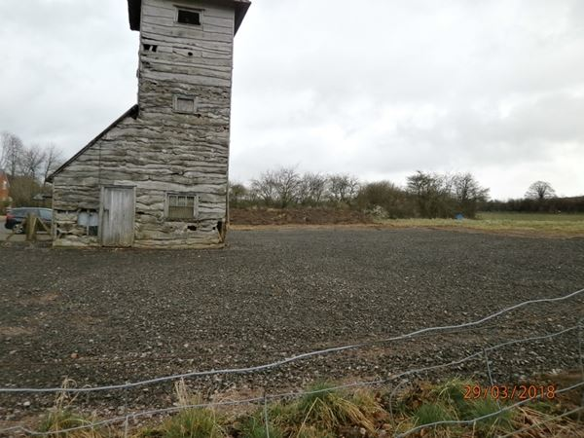

Test Valley Borough Council has won a legal battle to protect part of the countryside in Goodworth Clatford after enforcing a planning decision.
In 2018, a tarmac scalping hardstanding was laid around the water tower in the village. Although the tower isn’t a listed building, it is considered to be an important landmark feature of Goodworth Clatford, having been erected in 1936 and sits among attractive countryside.
Upon discovering that this had been done without permissions, the council advised the applicant to remove the tarmacked ground, and that this was likely to be rejected by the council if a retrospective planning application was submitted. Despite this advice, the applicant chose to submit an application having already carried out the work, but this was then refused, and a planning enforcement notice given.
This refusal of planning permission and the issuing of an enforcement notice was then appealed, but the Planning Inspectorate found in the council’s favour earlier this year as it breached planning policies in the council’s Local Plan. Having been given three months to remove the tarmac and restore the land, the defendants failed to fully comply, and the council began a prosecution process, which resulted in a successful day in court last month.
Enforcement is often a difficult and lengthy process but the Council is prepared to use all its available powers if required. If any Parish Council in Mid Test would like a briefing session on enforcement from the Head of Planning please contact us.

Our Contact Details
Councillor Ian Jeffrey cllrijeffrey@testvalley.gov.uk 01794 388872
Councillor Alison Johnston cllrajohnston@testvalley.gov.uk 01794 500610
Councillor Tony Ward cllrtward@testvalley.gov.uk 01794 389649

