Swaffham Town Council

Minutes of the Open Spaces Committee Meeting held on Monday 10th June 2019 at 6.30pm in the Council Chamber, Town Hall, Swaffham

Committee Members: Cllr J Skinner (in the chair)
Cllrs L Beech, W Bensley, B Holmes, I Pilcher, K Sandle

Councillors: P Darby (substitute for G Edwards) S Matthews

Swimming Pool
Association: S Skinner, P Medlock

Deputy Clerk: Mrs C Smith
Office Administrator: Mrs H Duggan

- Apologies for Absence.
Cllr G Edwards – work commitments
Mrs S Palmer – work commitments.

- Declarations of interest.
There were no declarations of interest.

- Minutes
The minutes of the Open Spaces Committee held on 20th May 2019 were agreed and signed as an accurate record by the Chairman.

- Terms of reference for extension of identity to incorporate sports and leisure
It was noted by the Committee that the wider topic of Council meetings and Committees would be on the agenda for the Full Town Council meeting on 12th June. Concerns were expressed regarding ‘leisure, health and well-being’ in the title of committees as these services were not within the remit of the Town Council. These issues would be debated and resolved upon by Full Council.

- Late or urgent matters at the Chairman’s discretion, not included elsewhere on the agenda
The Mayor had agreed to allow two additional items. Information had been circulated prior to the meeting to all Councillor committee members.

5.1 Dog walkers on the Recreation Ground.
Following the issues raised at the last meeting, Cllrs Pilcher and Edwards, had conducted a survey of the Recreation Ground playing field. They had found evidence of dog poo and some bins possibly not in the best locations as some of the exits did not have a bin near them.
The Deputy Clerk clarified that Breckland serviced the bins on the Rec and we would need to work with them to change any locations. Any new bins would need to be serviced by the Town Council.

PSPO – the Deputy Clerk had made initial enquiries to Breckland in this regard and awaited further response. It was noted the PSPO in question was about dogs being kept on leads and not about banning dogs altogether. The previous Open Spaces Committee had asked that posters requesting dogs to be kept on a lead be placed on the Rec, these were removed by persons unknown. The PSPO initial enquiry was also to look at tackling nuisance drinking, it was thought by Cllrs that this was unnecessary as Police already had the power to do this. The Deputy Clerk would ask the Police if this protection order was a useful tool.
Recreation Ground perimeter - work was in plan to block up and secure the perimeter of the Recreation Ground, along the Southland side with additional shrubbery, a security improvement identified by the Police. Once completed there would be more opportunity to review Recreation Ground exits and bin locations.

5.2 The Shambles – a note of initial thoughts regarding The Shambles area was circulated at the meeting – see Appendix 1.
The Deputy Clerk advised that the notes had been shared with the Events Project Support Officer as it could help with future Farmers Market or event plans for the town.

- Report from the representatives of Swaffham Swimming Pool; and consider making recommendation to full Council re-land previously allocated for the building of a swimming pool adjacent to the Green Britain Centre
The Chairman & Vice Chairman of the Swimming Pool Association attended and provided a summary of their progress to date, including discussions with Sport England and Breckland Council and current position. See Appendix 2
Mrs Sarah Skinner and Mrs Pam Medlock were thanked for attending and delivering an update.
Cllrs discussed the report, Breckland’s lack of support and access issues. A proposal was put forward by Cllr Sandle, seconded by Cllr Beech to make a recommendation to Full Council to continue to set aside the previously agreed land adjacent to the former Green Britain Centre for the Swimming Pool Association.

It was agreed 6 votes for, 1 abstention that a recommendation to Full Council be made to continue to set aside the previously agreed land adjacent to the former Green Britain Centre for the Swimming Pool Association.

It was reported that a neighbouring farmer had been farming the land and that there was no rental agreement in place. This situation was being investigated by the Town Clerk.

- Breckland land / open space owned or managed in our town
The Deputy Clerk reported that the Town Clerk had asked Mr Ralph Burton, a Breckland officer, for an up to date map of Breckland assets in Swaffham. It was unclear if Breckland would share any financial information regarding the assets, but the question would be posed when chasing a response.

- To agree date for the next meeting; and frequency of future meetings
As quoted in item 4, it was acknowledged by the Committee that the wider topic of Council meetings and Committees was on the agenda for the Full Town Council meeting on 12th June. It was suggested to keep the date for the next meeting in the diary for the time being.

- Next Meeting
The next meeting was confirmed as Monday 29th July 2019.

Meeting Closed at 7.20pm. Chairman…………………………..

Appendix 1
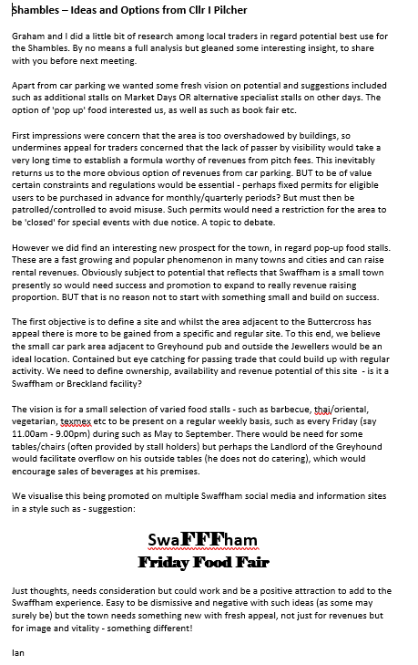
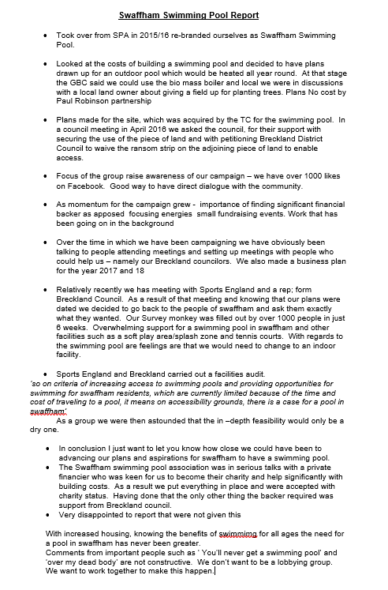
Appendix 2

