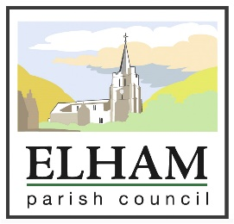
ANNUAL GENERAL MEETING
Monday May 21st 2018 at 7.30PM
ELHAM METHODIST HALL

AGM AGENDA

- To appoint Linda Hedley as Locum Clerk for the Meetings
- Apologies for Absence
- Declarations of Interest and Dispensations
- Election of Chairman and signing of Declaration of Acceptance of Office
- Election of Vice Chairman and signing of Declaration of Acceptance of Office
- Approval of the Minutes of the last AGM held on 8th May 2017
- Matters Arising from the Minutes
- Financial Report – provisional report (unaudited)
- Vacancy for Councillor

ORDINARY MEETING AGENDA

- Apologies for Absence
- Declarations of Interest and Dispensations
- Approval of the Minutes of the last meeting held on 9th April 2018
- Matters Arising from the Minutes
- Discussion of leisure and recreation spaces within the Parish
- Public Session
- Planning
  - APPLICATION NO: Y18/0602/FH: Copper Leas Boyke Lane Ottinge Canterbury - erection of a two storey extension to south west elevation along with alterations to the existing roof, installation of doors, windows and roof lights and widening of existing drive
- Finance – Authorisation of Payments
- Chairman’s and Councillors’ Reports
- Vacancy for Parish Clerk

Geoff Clements
Chairman

