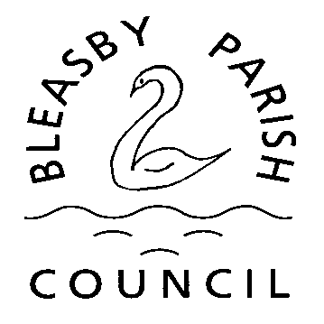

Bleasby Parish Council
c/o Belina Boyer – Clerk/RFO
3 Jackson Court
Farndon
Newark
NG24 3TS
07926124442
bleasbyparishcouncil@outlook.com

Application for use of the Glebe Field, Bleasby, for special Events

Name of Person organising the event

On behalf of organisation – please state if private event

Contact details

Date of event Time of event

What sort of event

If this is a fund-raising event, which charity/charities will benefit

Do you have insurance cover?
(Depending on the type of event, the Parish Council may request sight of your insurance
documents and any licences which may be required)

What arrangements are in place for ensuring the safety of people attending the event? For example first aiders, stewards.
(Depending on the type of event the Parish Council reserve the right to see any risk assessments or other documentation required to ensure the safety of members of the public using the field.)

Please sign below to confirm that you have read and agree to the
conditions of use of the Glebe Field. The decision of the Parish Council is final on all matters relating to the Glebe Field.

Please note that dogs are not permitted on the Glebe Field, except registered assistance dogs – for safety reasons glass drinking glasses are not to be taken on to the field.

Please return this form to the above address, at least six weeks prior to your event.

