Areas of High Archaeological Potential (AHAP) and Areas of Archaeological Potential (AAP). Source: Kingsclere Extensive Urban survey, 1998, Hampshire County Council/English Heritage’
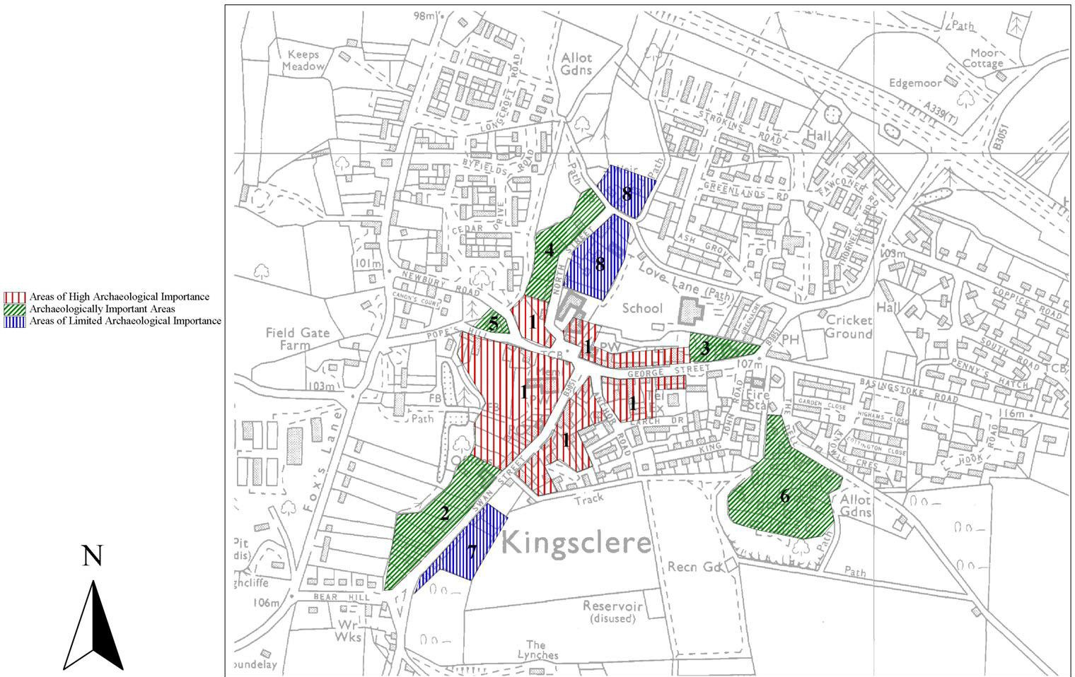

Crown copyright and database rights 2017 Ordnance Survey. Licence No 100019356

