BRECKLAND OPERATIONAL PARTNERSHIP TEAM
Elizabeth House, Walpole Loke, Dereham, NR19 1EE
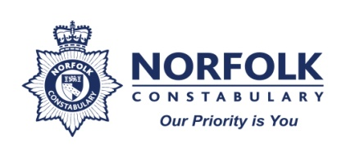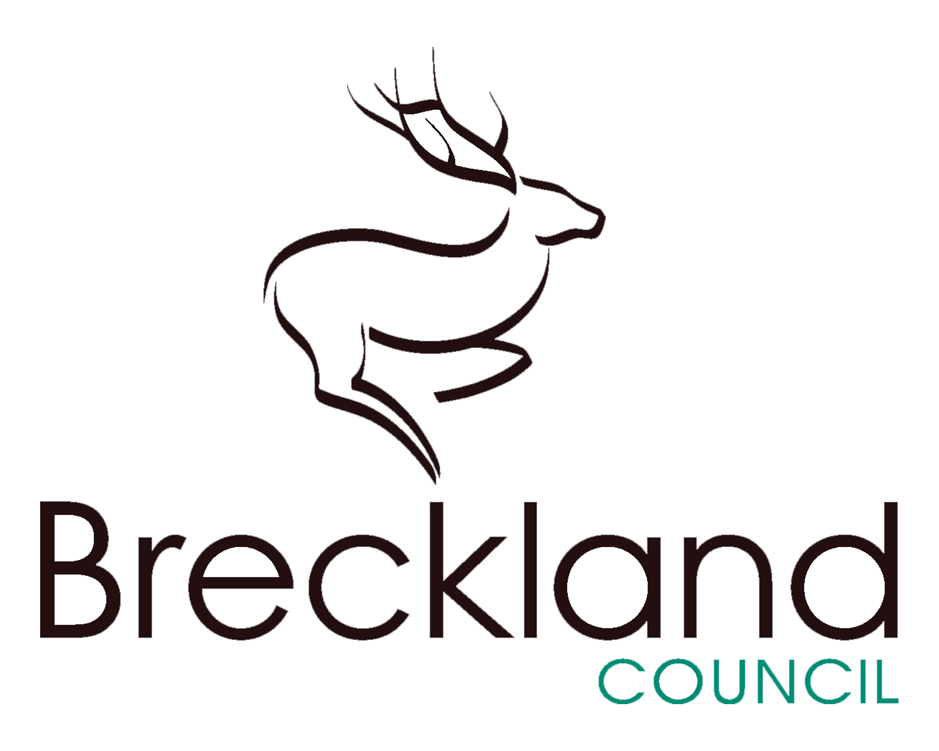

Breckland Operational Partnership Team

Improving Communities by Reducing Anti-Social Behaviour

Who are we?

A co- located team made up of officers from Breckland Council and Norfolk Constabulary.

The team currently consists of the following staff members:
- Tracey Baxter – Community Safety & ASB Officer (Breckland Council)
- Sgt Gareth Woodward – Norfolk Constabulary
- Graham Parfitt – ASB Technical Officer (Breckland Council)
- PC Natalie Cooper – Norfolk Constabulary
- PC Ray Kurn – Norfolk Constabulary
- Laura Parrott – Norfolk Constabulary – ASB and Early Help (Part time)

This was the first co-located Police and Council team set up to address anti- social behaviour in the County. It was established in 2010, and was the pilot Operational Partnership Team for Norfolk.

What do we do?

Our remit is to work in partnership to address anti-social behaviour in the district. We work closely with social landlords, Youth Offending Teams, other internal partners in the council such as Environmental Health, Environmental Services and Housing. We engage with support agencies such as Early Help teams, Change,Grow, Live and others who might also assist in resolving some of the underlying factors leading to anti-social behaviour.

The Breckland Operational Partnership Team works with both perpetrators of, and victims of anti- social behaviour and seeks to also identify and manage risk and vulnerability in both.

Work With Perpetrators
Where individuals are identified as acting anti socially, we use early intervention to try to prevent the harm. If warnings are not heeded and help offered not accepted, then we have new ASB tools and powers available to us to ensure that issues are addressed. Thankfully, early intervention does work in many cases, and often prevents the need for an escalation to enforcement action.

Work With Victims
Victims of anti-social behaviour are risk assessed and given support and assistance appropriate to their needs. We listen to them, we take their complaints seriously, and we develop an action plan with other relevant professionals to detail how we will address their issues. We share this with them and update on progress throughout our investigations.

Impact of ASB on Victims

In our experience, we have seen that anti-social behaviour impacts greatly on those affected by it. On the face of it, a lot of the things we deal with may be deemed low level, but on the victim, the impact will almost certainly be quite high. By it’s very nature, this type of behaviour is often persistent and ongoing. Mental and physical health is often affected and people often feel unable to easily get over what they have endured.

Nearing the end or post anti-social behaviour case, we have through our innovative Victim focused project, ‘ Moving On’, been able to acknowledge the detrimental effects a sustained period of anti -social behaviour can have on an individual. We have offered them a way of leaving behind the legacy ASB brings by helping to improve their health & well- being. This has been by offering things such as swim passes, museum passes, garden equipment, or even the provision of cycles etc.

This project was initiated by the Breckland Operational Partnership Team and supported by Norfolk Constabulary’s Chief Constable, Simon Bailey, who provided some funding to help take it forward. Parkwood Leisure and the Museums Service have also helped support the project by offering discounted passes to their facilities.

Educational Interventions

We are unique in that each year we commission and provide a tailored delivery of anti-social behaviour interventions in several junior schools throughout our district. These educate young people in year’s 5 & 6 about anti-social behaviour and it’s consequences. In year 5, children learn through interactive magic and performance about choice, consequence and peer pressure. YBYZ (pronounced Why be wise?) answers the question ‘what happens to me if I behave anti-socially’. Following on from that, in year 6, the children are able to explore victim impact, and can work through what it feels like to put themselves in the shoes of a victim and discuss instances where they themselves may have been victims in their own lives. This presentation if called ‘Why me?’. We have worked with schools to ensure that these presentations are relevant and engaging and have received and continue to receive excellent feedback from the staff and pupils involved.

Why we do it?

As a local authority we have a statutory duty to address crime and disorder and anti-social behaviour in partnership with other agencies and authorities. This was set out in the Crime and Disorder Act of 1998, the Anti-Social Behaviour Act of 2003 and most recently The Anti-Social Behaviour, Crime & Policing Act 2014.

Benefits of Co-Location

By working closely with our Police partners we can:

- Provide a quicker and more timely response for our victims
- Share information more effectively
- Provide the public with another reporting mechanism ( often our victims are worried about reporting issues directly to the Police, or do not want to visit a police station)
- Share the management of risk and vulnerability identified in our victims
- Share our skills and expertise
- Offer, when necessary, other enforcing areas of the Council on site expertise, information and the first hand advice of Police staff.

If you wish to discuss the work of the Operational Partnership Team or would like any further information about the work that we do or the partners we do it with, we can be contacted on either by phone or email, as detailed below:
Team Contact Details:

Tracey Baxter – 01362 656891 – tracey.baxter@breckland.gov.uk
Sgt Gareth Woodward – 01362 656361 – gareth.woodward@norfolk.pnn.police.uk
Graham Parfitt – 01362 656383 – graham.parfitt@breckland.gov.uk
PC Natalie Cooper – 01362 656870 - natalie.Cooper@norfolk.pnn.police.uk
PC Ray Kurn – 01362 656870 – Raymond.kurn@norfolk.pnn.police.uk
Laura Parrott – laura.parrott@norfolk.pnn.police.uk

