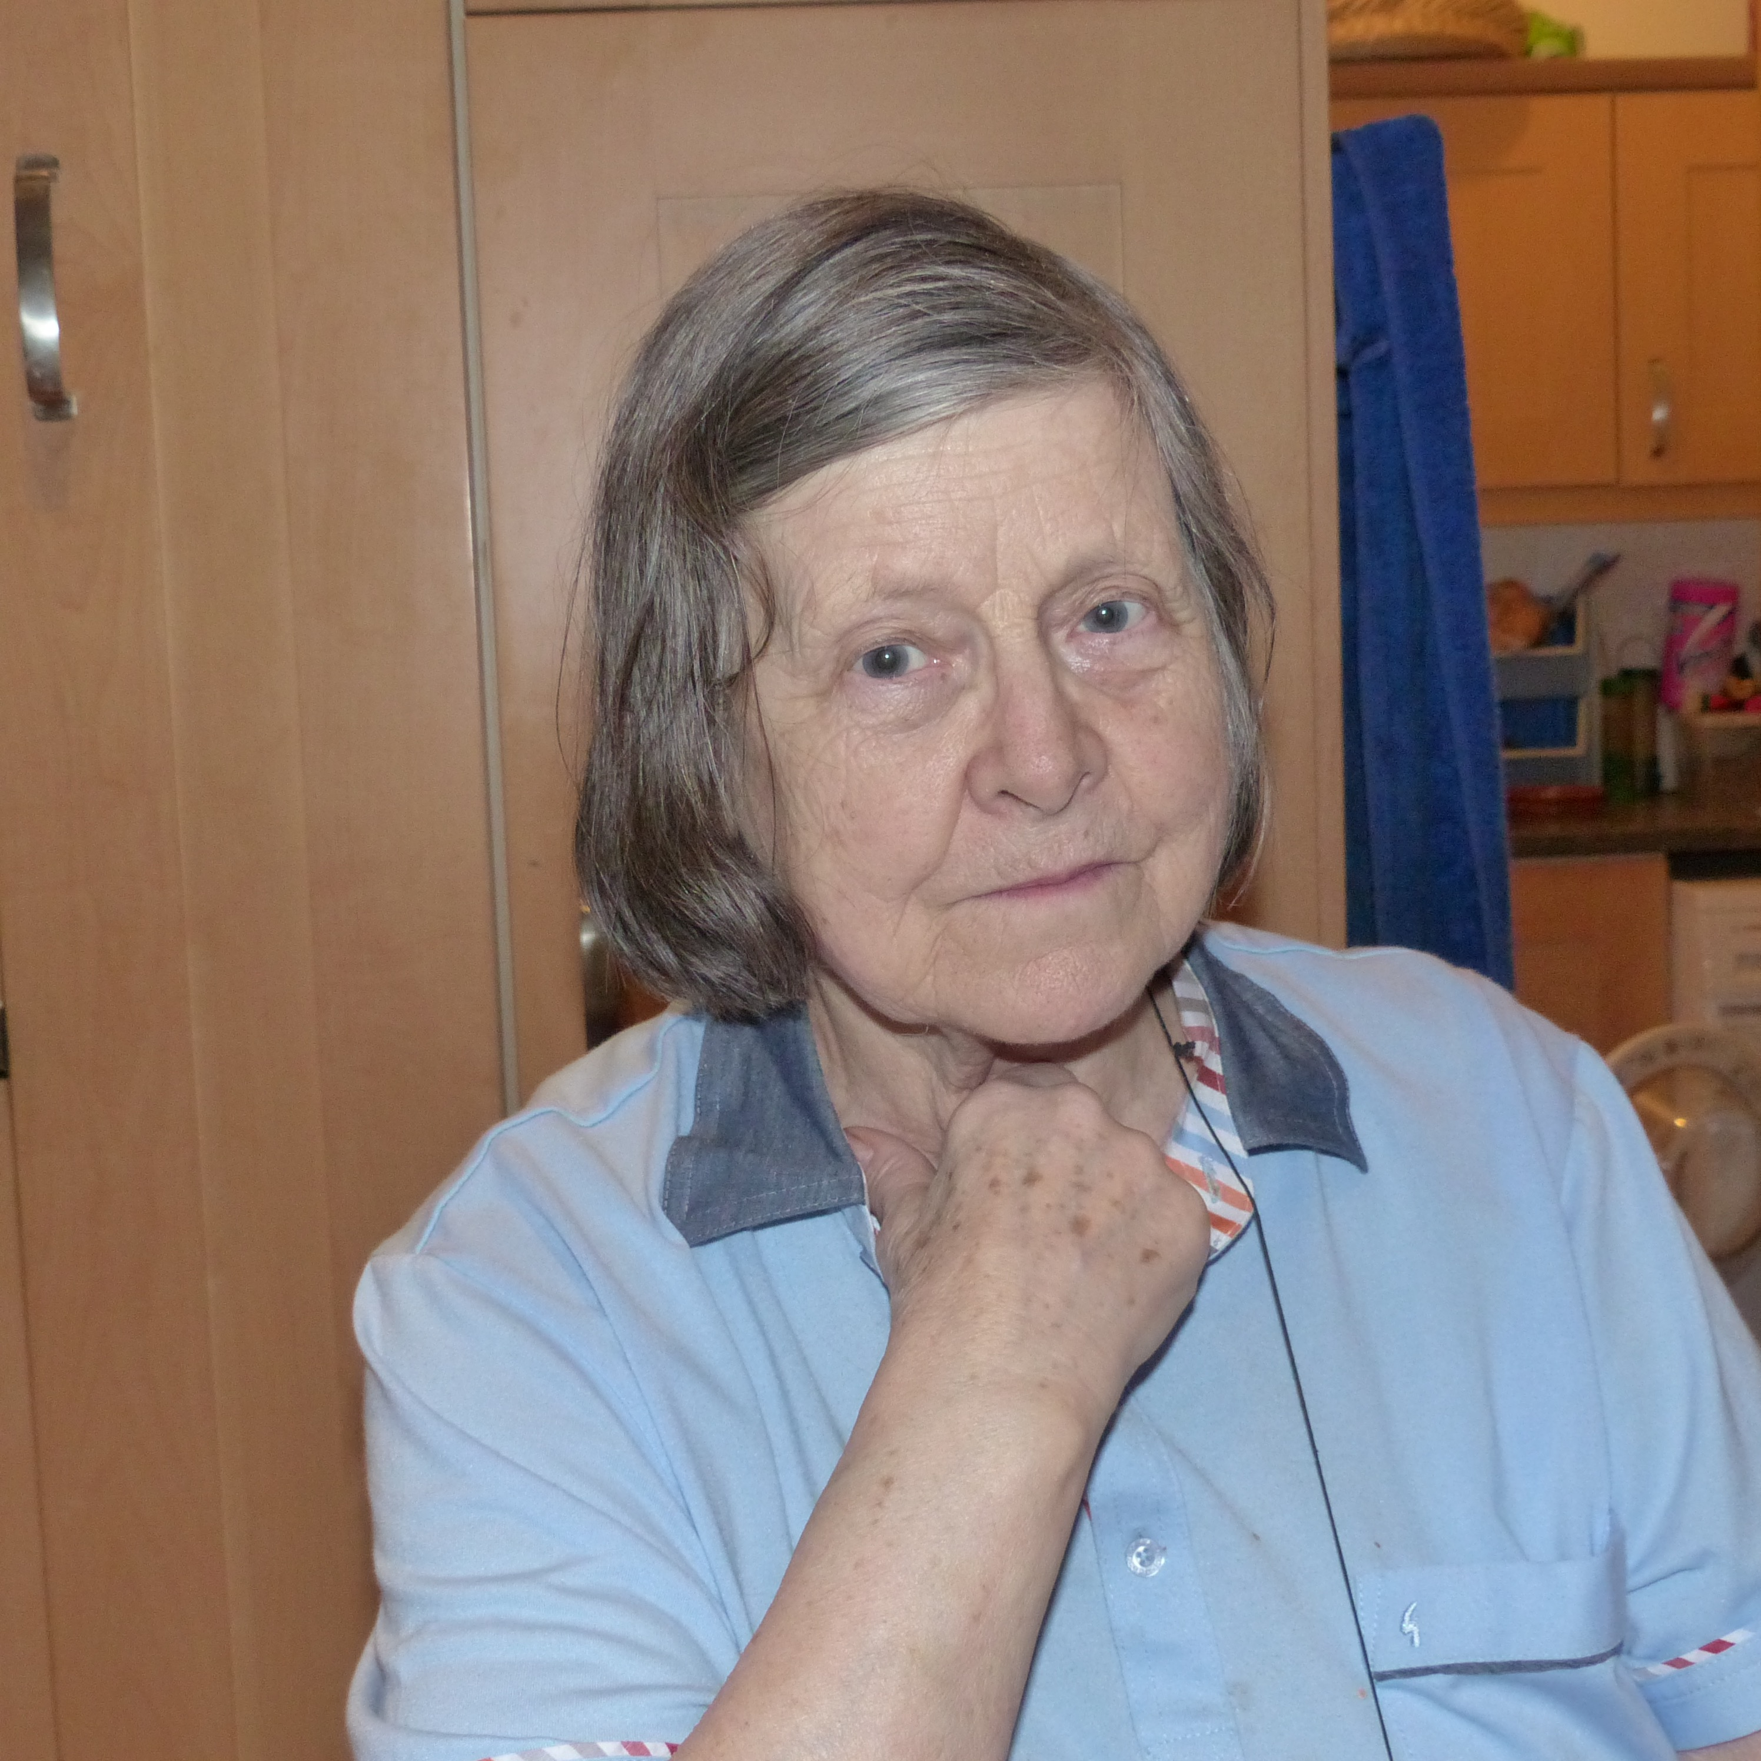
Johnson Fiona

Index number: MWOH002005

Recorded on: Thursday 28th January 2016 by Anne Weaver and Roger Davis.
Time commenced: 10.00 Duration: 35 minutes Location: The Coach House, Old Dene, Westhumble.

Fiona was born in London and following her Mother’s evacuation to Surrey the family settled in Merrow and then moved to Westcott. When she was first married she spent 2 or 3 years near Scunthorpe and then Sheffield. On returning to Surrey they spent 18 years at Norbury Park Farm before moving to Old Dene. Due to her husband, Colin, becoming unwell they have lived in the Coach House for the last 10 years. Fiona then tells us during the war years that apart from washing up, her involvement in the kitchen was minimal although she did pick rose hips, blackberries and crab apples. As she had not been taught to cook by her mother she relied on a Good Housekeeping cookbook to aid her when she was first married. We then hear about wartime rationing and how her mother used the sugar ration to make basic cakes, and that she divided the butter ration into named pots. Although there was plenty of milk, potatoes and cabbage, roast dinners were a rarity, however stews were eaten most days. Food continued to be scarce after the war and it was necessary to be registered with a butcher to use your meat coupons. Fiona recalls that due to lack of training and lack of cookbooks, her mother was not able to make good use of “off ration” meats such as offal. As petrol was rationed trips to obtain food were made by bicycle, usually every other day. Although apples were plentiful, the old varieties available were often poor quality, but they could be preserved by bottling. Again poor varieties, together with the cold wet climate, meant that tomatoes were a rarity. Fiona tells us that in the 1950’s food became more widely available and that there such a high demand when sweets came off rationing that they were promptly put back on. She then discusses the availability of meats such as chicken and lamb and the gradual reintroduction of fruits from abroad. There was also an increase in the supply of eggs due in part to the introduction of battery hens. On moving to Norbury Park Farm in 1965 we are told that they were saving hard and that money was in short supply but Fiona estimates that 50% of their food was home produced. This included eggs from about 20 ex battery hens and milk from their dairy herd of 60 milking cows. Geese were also kept on the farm but were not very profitable and Fiona tells us that she became too fond of them to slaughter. Day old cockerel chicks however were obtained, sometime free of charge, and fattened to eat.

Processed food was not bought however a friend, who worked in the canteen at the Ronson’s factory, would occasionally provide surplus food such as yogurt and sliced ham, which was a great treat. Although Fiona did not have a farming background, Colin parents were farming Norbury Park Farm. Colin would do the relief milking if the 2 herdsmen were off. He would milk the cows at 4.00 a.m. before having breakfast and then commuting to London to work, returning in time for the afternoon milking. Although cows were kept they would be sent off to slaughter and never eaten at the farm. We then hear how the advent of the freezer changed food provision as previously much food was preserved in jars. Returning to her recollection of the war years, Fiona tells us that she collected rose hips, which were then sold at the local chemist as they were a good source of vitamin c. Attention then turns to discussing home produced wine and home brewed beer which was often imbibed at parties and special events. Before Colin’s illness Fiona bought very little processed food, instead she bought a lot of meat and exotic fruits when they were in season. She reminisces about the first time that she saw a banana and of the scarcity of other fruits such as oranges. Following which we hear about her efforts of keeping goats and of her disappointment with their milk and their reluctance to finish of the roughage after the horses had grazed a field, preferring sheep to do this. We return to the subject of alcohol and the parties held by her children. Then turning to her current food preparation she tells us that she finds convenience food useful, as they are well suited to Colin’s variable appetite. We hear how special meals such as Christmas are family occasions and she recalls the large parties held by her children and subsequently her grandchildren, who enjoy catering for themselves. Fiona praises the younger generation for their adventurous cooking and believes that they are more now responsible about alcohol consumption that previously. We hear the story of her youngest sons attendance at a party at which everything was consumed and the fridge left empty. She believes now however that young people now eat responsibly, and she notes that compared with the past they have a very wide choice but eat sparingly.

