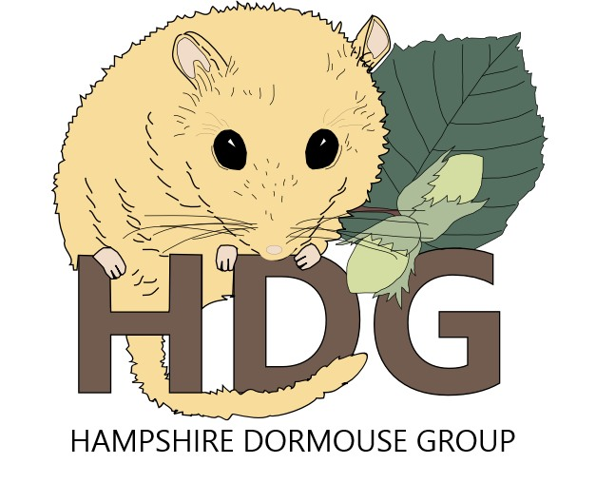
TRAINING BOOKING FORM
Course Title | Dormouse Ecology and Conservation Training Course
Date | 7th 14th & 21st March
Venue | MS Teams
Start Time | 7pm (1900)
Length | 3 X 2 hrs
Cost | Member | £20 | Non-Member | £30
Please Complete the Information Below
Name
E-mail
Phone (mobile)
Member Status | Member |  | Non-Member
Payment
Bank Transfer | Account Name: | Hampshire Dormouse Group
 | Bank: | Co-operative Bank
 | Account Number: | 65717846
 | Sort Code: | 08-92-99
 | Reference: | Please use your surname and TC  e.g. Fred Bloggs = BLOGGSTC

If you need or would prefer to pay by other methods, please send us a message when returning your form.

Forms to be returned to: Kathryn.Steele@outlook.com

