WALLOP BROOK UPDATE

Members of the working group are Ian Courcoux and Janet Herring

We have been gathering information that might inform the Neighbourhood Planning document further.

Simon Cooper, Fishing Breaks: Suggests that ‘we’ ask him our top five questions we’d like answering about the Brook – we will need to email him these questions as he is currently out of the country. What should these questions be?

Jeremy has suggested the following:
The following are the questions that occur to me:

- Who is responsible for removal of weeds which clog up the brook? This used to be done by the river authority, but I save not seen them recently. (JH could we also ask about seasonality about maintenance as last year we lost the Orange Tipped Butterfly eggs and it may be good to know when the water voles have their babies etc – perhaps there could be an advisory maintenance policy?)
- Is there an optimal level of plant growth in the stream, e.g. to provide shade for fish and homes for water voles?
- Are there regular tests to check pollutants? Farm chemicals? Who does this?
- Are there any measures being taken to control the growth of American Signal Crayfish? There appears to be an ambivalent policy banning trapping (in case the smaller indigenous crayfish get caught, released and infect their already dwindling numbers)? Madness, as I have not seen an indigenous one in years. We should encourage trapping these pests, which can be eaten!
- Has the abstraction from the Brook (towards Broughton) by the Water Authority been stopped and are water levels being maintained?

Dagan James from Broughton Buffalo put me in touch with Alison Cross who leads on the Wallop Brook Farmers initiative & H&IOW Wildlife Trust:

Alison said:

I think the key things are: The Wallop Brook is a largely undesignated landscape which links some hugely important areas: Test SSSI and Porton Down SAC and SSSI. As such, the protection of local wildlife sites and creation of stepping stone and corridors, rewilding of areas is critical to the nature recovery network.

The wallop is a tributary of the Test and as a small and very defined catchment, land use has an immediate impact on the SSSI
It has some outstanding wildlife populations: rare arable flora, corn bunting (prob the stronghold in all of Hampshire)

Dagan said it is like all chalk streams a very important landscape and ecological feature of our area.

Susan Simmonds from H&IOW Wildlife Trust recommended the landscape character description from TVBC,

https://www.testvalley.gov.uk/planning-and-building/treesandlandscape/test-valley-community-landscape-project/volume-1-description-and-classification-of-landscape-character-types-and-area/landscape-character-types-and-areas/lct5-river-valley-floor?chapter=7
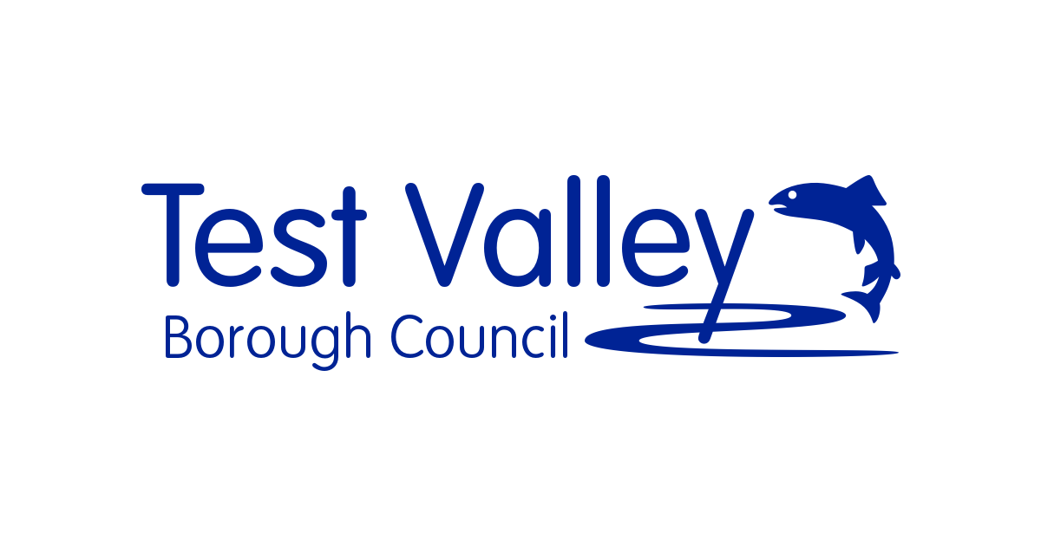 | LCT5 River Valley Floor | Test Valley Borough Council  LCA5F Wallop Brook Valley Floor General Description. The Wallop Brook Valley Floor is a narrow valley with a relatively shallow gradient with variations in scale and character that typify the landscape character.  www.testvalley.gov.uk
This HCC document explains the importance of the area and covers biodiversity on Page 6. The key point is that The Wallop Brook is a tributary of The Test which is a SSSI and an SAC under European law. https://documents.hants.gov.uk/landscape/HICACharacterArea-3BTestValley-Final2012-05.pdf.

Flood Management and Water Flow
We also believe that the Wallop Brook and its tributaries are essential for the flood management of many of the parish residential properties and local fields. Management of the riparian land will be key to ensuring the flow of water, local wildlife whose home it is (Water voles) and any development must be considerate of not impacting in other areas within the parish.

Wildlife
The brook is key for species such as water voles, kingfisher, egrets, butterfly egg laying – otter….

Later in 2021 a River Fly survey is going to be taken by HIWWT trained volunteers.

