(NAME):
COONCI
Notice of conclusion of the audit
- The audit of accounts for the CouncilA4eeGtg-6) for the year ended 31 March 2017 has been concluded.  - The Annual Return is available for inspection by any local government elector of the area of the Council 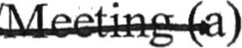on application to:  (b) (300 ^{c}o  cweu OAWLC  2. Copies will be provided to any local government elector on payment of for each copy of the Annual Return.  Announcement made by: (d)  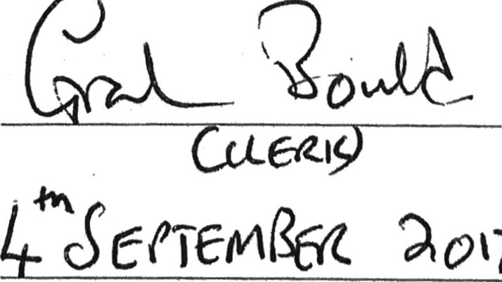  Date of announcement: (e) 2017 | Notes  - Delete as appropriate  - Insert name, position and address of the person to whom local government electors should apply to inspect the Annual Return  - Insert a reasonable sum for copying costs  - Insert name and position of person placing the notice  - Insert date of placing of the notice
Annual Return for the year ended 31st March 2017
Section 25 of the Local Audit and Accountability Act 2014 Accounts and Audit (England) Regulations 2015
— Annual governance statement 2016/17
We acknowledge as the members of:
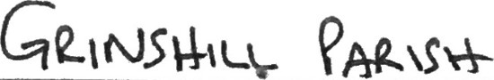 Covryc-lt.—
Enter name of smaller authority here:
our responsibility for ensuring that there is a sound system of internal control, including the preparation of the accounting statements. We confirm, to the best of our knowledge and belief, with respect to the accounting statements for the year ended 31 March 2017, that:

- We have put in place arrangements for effective financial management during the year, and for the preparation of the accounting statements.
- We maintained an adequate system of internal control, including measures designed to prevent and detect fraud and corruption and reviewed its effectiveness.
- We took all reasonable steps to assure ourselves that there are no matters of actual or potential non-compliance with laws, regulations and proper practices that could have a significant financial effect on the ability of this smaller authority to conduct its business or on its finances.
- We provided proper opportunity during the year for the exercise of electors' rights in accordance with the requirements of the Accounts and Audit Regulations.
- We carried out an assessment of the risks facing this smaller authority and took appropriate steps to manage those risks, including the introduction of internal controls and/or external insurance cover where required.
- We maintained throughout the year an adequate and effective system of internal audit of the accounting records and control systems.
- We took appropriate action on all matters raised in reports from internal and external audit.
- We considered whether any litigation, liabilities or commitments, events or transactions, occurring either during or after the year-end, have a financial impact on this smaller authority and, where appropriate have included them in the accounting statements.
- (For local councils only) Trust funds including charitable. In our capacity as the sole managing trustee we discharged our accountability responsibilities for the fund(s)/assets, including financial reporting and, if required, independent examination or audit.
This annual governance statement is approved by this smaller authority on:

15/os/17
and recorded as minute reference:
Agreed |  | 'Yes'
,Yes |  | means thatihis smaller authority:  prepared its accounting statements in accordance with the Accounts and Audit Regulations.  made proper arrangements and accepted responsibility for safeguarding the public money and resources in its charge.  has only done what it has the legal power to do and has complied with proper practices in doing so.  during the year gave all persons interested the opportunity to inspect and ask questions about this authority's accounts.  considered the financial and other risks it faces and has dealt with them properly.  arranged for a competent person, independent of the financial controls and procedures, to give an objective view on whether internal controls meet the needs of this smaller authority.  responded to matters brought to its attention by internal and external audit.  disclosed everything it should have about its business activity during the year including events taking place after the year-end if relevant.
Yes | No | has met all of its responsibiliti s where it is a sole managing trustee of a loc trust or trusts.
Signed by Chair at meeting where appro given:
Clerk:

*Note: Please provide explanations to the external auditor on a separate sheet for each 'Not response. Describe how s smaller authority will address the weaknesses identified.
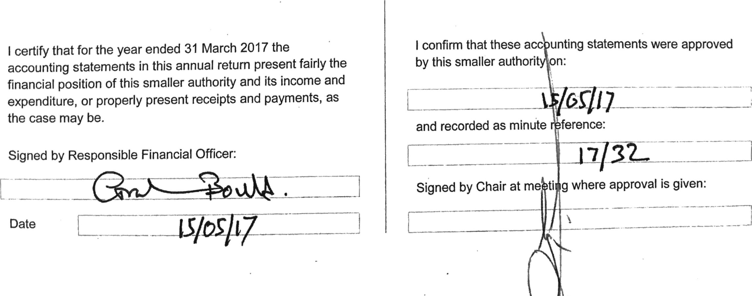
— Accounting statements 2016/17 for
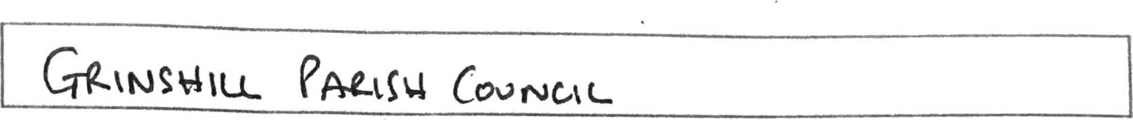
Enter name of smaller authority here:
 | Narc | ending  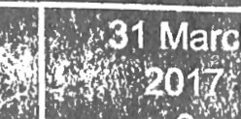 |  |  |  |  |  |  | Notes and guidance
Please round all figures to héarest Éi : b0'rLt leave any boxes blank
•and report EO or Nil balances. Al ägregtp financial records.
1. Balances brought forward | 1 57 | 32 |  |  |  |  |  |  | Total balances and reserves at the beginning of the year as recorded in the financial records. Value must agree to Box 7 of previous year.
2. (+) Precept or Rates and Levies | 19 08 | 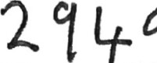 |  |  |  |  |  |  | Total amount of precept (or for IDBs, rates and levies) received or receivable in the year. Exclude any grants received.
3. (+) Total other receipts | L Lpq€ | 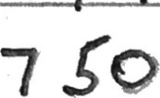 |  |  |  |  |  |  | precept or rates/levies received (line 2). Include any grants received.
4. (-) Staff costs | L IBIS | 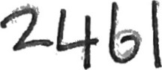 |  |  |  |  |  |  | Total expenditure or payments made to and on behalf of all employees. Include salaries and wages, PAYE and NI (employees and employers), pension contributions and employment expenses.
5. (-) Loan interest/capital repayments |  | IVIE |  |  |  |  |  |  | Total expenditure or payments of capital and interest made during the year on the smaller authority's borrowings (if any).
6. (-) All other payments | 1 3 101 |  |  | 06 |  |  |  |  | Total expenditure or payments as recorded in the cashbook less staff osts (line 4) and loan interest/capital repayments (line 5).
7. (=) Balances carried forward | 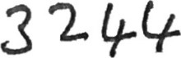 |  |  |  |  |  |  |  | tal balances and reserves at the end of the year. Must equal  1 +2+3) — (4+5+6)
8. Total value of cash and short term investments | 32 | 3 |  |  |  |  |  |  | he sum of all current and deposit bank accounts, cash holdings and short term investments held as at 31 March — To agree with bank reconciliation.
9. Total fixed assets plus long term investments and assets | I Ito |  |  |  |  |  |  |  | This cell shows the value of all the property the authority owns. It is made up of its fixed assets and long-term investments.
10. Total borrowings | NIL |  |  |  |  |  |  |  | The outstanding capital balance as at 31 March of all loans from third parties (including PWLB).
11. (For Local Councils Only) Disclosure note re Trust funds (including charitable) |  |  | Yes |  |  | No |  | The Council acts as sole trustee for and is responsible for managing Trust funds or assets.  N.B. The figures in the accounting statements above do not include any Trust transactions.
— External auditor report and certificate
In respect of:
Sl..hu__ 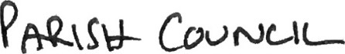
Enter name of smaller authority here:
1. Respective responsibilities of the body and the auditor
This smaller authority is responsible for ensuring that its financial management is adequate and effective and that it has a sound system of internal control. The smaller authority prepares an annual return in accordance with proper practices which:
- summarises the accounting records for the year ended 31 March 2017; and
- confirms and provides assurance on those matters that are relevant to our duties and responsibilities as external auditors.
Our responsibility is to review the annual return in accordance with guidance issued by the
National Audit Office (NAO) on behalf of the Comptroller and Auditor General (see note below). Our work does not constitute an audit carried out in accordance with International Standards on Auditing (UK & Ireland) and does not provide the same level of assurance that such an audit would do.

2.2016/17 External auditor's report
On the basis of our review of the annual return, in our opinion the information in the annual return is in accordance with proper practices and no other matters have come to our attention giving cause for concern that relevant legislative and regulatory requirements have not been met.
Other matters not affecting our opinion which we draw to the attention of the smaller authority:
In the Accounting statements 2016/17, the balances carried forward did not initially equal (1+2+3) (4+5+6). The entries at Boxes 7 and 8 were overstated by 295, which also meant Box 8 did not agree with the bank reconciliation. In future, the Council should ensure the annual return adds up before submission.

2016/17 External auditor certificate
We certify that we have completed our review of the annual return, and discharged our responsibilities under the Local Audit and Accountability Act 2014, for the year ended 31 March 2017
External auditor signature:
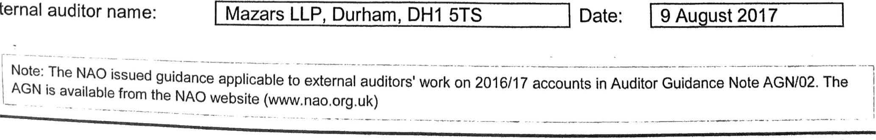
External
Page 4 of 6

Enter name of smaller authority here:
This smaller authority's internal audit, acting independently and on the basis of an assessment of risk, carried out a selective assessment of compliance with relevant procedures and controls expected to be in operation during the financial year ended 31 March 2017.
Internal audit has been carried out in accordance with this smaller authority's needs and planned coverage. On the basis of the findings in the areas examined, the internal audit conclusions are summarised in this table. Set out below are the objectives of internal control and alongside are the internal audit conclusions on whether, in all significant respects, the control objectives were being achieved throughout the financial year to a standard adequate to meet the needs of this smaller authority.
Internal ntqol objectiv Agreed? Please choose only
.3öne of the following
Yes No* covered"
- Appropriate accounting records have been kept properly throughout the year.
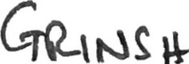lu— | e | C-vvr•oe-l
- This smaller authority met its financial regulations, payments were supported by invoices, all expenditure was approved and VAT was appropriately accounted for.
C.  D.  E.  F.  G.  H.  J. | This smaller authority assessed the significant risks to achieving its objectives and reviewed the adequacy of arrangements to manage these.  The precept or rates requirement resulted from an adequate budgetary process; progress against the budget was regularly monitored; and reserves were appropriate.  Expected income was fully received, based on correct prices, properly recorded and promptly banked; and VAT was appropriately accounted for.  Petty cash payments were properly supported by receipts, all petty cash expenditure was approved and VAT appropriately accounted for.  Salaries to employees and allowances to members were paid in accordance with this smaller authority's approvals, and PAYE and NI requirements were properly applied.  Asset and investments registers were complete and accurate and properly maintained.  Periodic and year-end bank account reconciliations were properly carried out.  Accounting statements prepared during the year were prepared on the correct accounting basis (receipts and payments or income and expenditure), agreed to the cash book, supported by an adequate audit trail from underlying records and where appropriate debtors and creditors were properly recorded.
K. | (For local councils only)  Trust funds (including charitable) — The council met its responsibilities as a trustee. | Yes | No | Not applic?ble
For any other risk areas identified by this smaller authority adequate controls existed (list any other risk areas below or on separate sheets if needed)
