Her Majesty Queen Elizabeth II

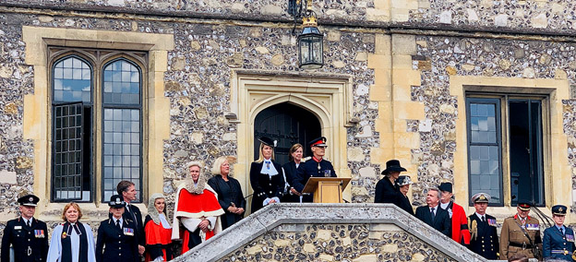

We were all devastated to hear the terrible news about the Queen. Her life has been dedicated to public service and she has led the Country and the Commonwealth with unstinting dedication throughout her reign. She has been the one constant for the entire life of almost everyone in the nation, a beacon of calm, fortitude and continuity in an ever changing and often challenging world. She will be greatly missed.

Hampshire to increase monthly payments to local residents hosting Ukrainian families

Hampshire County Council has today announced that it will be paying an extra £200 per month to Hampshire residents hosting Ukrainian guests as part of the Government’s Homes for Ukraine Scheme, over the next five months.
The new payments will start in October and be funded via the grant paid to upper tier local authorities to support implementation of the Homes for Ukraine scheme locally.
The county of Hampshire has welcomed the third highest number of Ukrainian nationals in England.
https://www.hants.gov.uk/News/20220928ukrainehostpayments

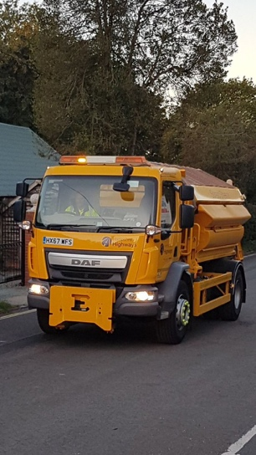
Getting ready for winter

It's not winter yet, but don't be surprised to see Hampshire County Council gritters out and about over the next few weeks.

Gritting vehicles will be out on trial runs on priority one salt routes to ensure we are ready for the start of the winter season.

Should you see the gritters on your travels, although not salting, please give them plenty of space.

For more information on our salt routes please follow the below link: https://maps.hants.gov.uk/highwayssaltroutes/

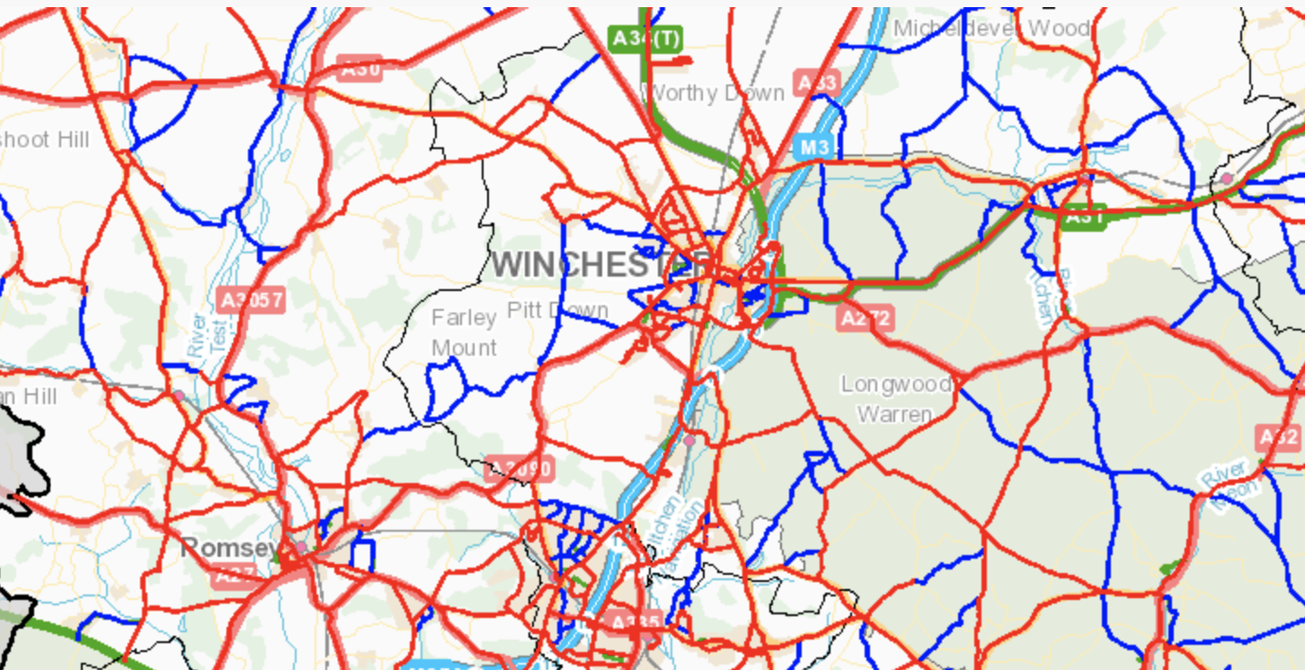

Driver Skills Scheme for older drivers.

With the colder season just around the corner and low sun, poor weather conditions and mechanical strain on vehicles, drivers are often advised by motoring organisations to get their vehicle checked. But, what about the driver? HCC’s Road Safety team's experienced assessors are on hand to provide some useful tips for winter driving.
Mature drivers generally have fewer accidents than young drivers. However, as we grow older, gradual changes take place which mean our ability to deal safely with some situations diminishes. The ‘Driver Skills Scheme’ is a confidential skills appraisal for drivers aged over 60.
Find out how it could help you or someone close to you:-
https://www.hants.gov.uk/.../drivertraining/driverskills

Hampshire County Council team shortlisted in Social Worker of the Year Awards

Work by a Hampshire County Council social care team to help young people with complex needs make the transition to adulthood has gained national recognition – having been shortlisted in the annual Social Worker of the Year Awards.
Hampshire County Council’s Independent Futures Team (IFT) is a finalist in the Team of the Year Adult Services category. The IFT supports around 150 young people every year with their transition into adulthood and independent living. Comprising eight social care practitioners, the team provides personalised support plans for each young person referred to them, as well as support from a dedicated worker to help each young person to grow and flourish in the next phase of their lives.
https://www.hants.gov.uk/News/20220926AHCaward

Cllr David Drew
Test Valley Central Division, HCC

