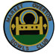MARKET OVERTON BOWLS CLUB

Invite you to the return of

7 pm for 7.30 pm START
Saturday 12th August 2017
Tickets £5
supporting 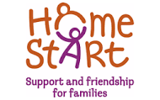

Disabled wc and access

Tickets from Bar during Club open hours or Tel: 01572 812233

