PETROCKSTOWE PARISH COUNCIL
Parish Clerk: Fiona Lowe, Rose Farm, Petrockstowe, Okehampton EX20 3HQ
Phone: 01837 811749 E-mail: petroc.clerk@hotmail.com

Dear Councillors
You are duly summoned to attend the Petrockstowe Parish Council Meeting to be held at 8pm on Tuesday 27th September 2016, in the Meeting Room at the Chapel, Petrockstowe, to discuss the following business.

AGENDA

- Apologies of Absence. To receive any apologies

- Declarations of interest

- Public Session

- Minutes. To consider the approval of the minutes of the Annual General Meeting of 26th July 2016, having been previously supplied.

- Planning. Planning applications since 26th July.

- Councillors Reports for information.
- Recreation Ground – Cllr Kelsey
- Play Area – Cllr Jeffs
- Baxter Hall – Cllrs Busby / Harris
- County / District – Cllrs Boyd / Wiseman
- Police Report – PSCO Baxter

- Matters arising from previous minutes.
- The Square proposal and Land Registry
- Clay Lorries driving through the village – update Clerk
- Website – update Clerk
- Queen’s 90th Birthday Medals – Update Cllr J Harris
- Precept/Lease Payments – thanks

- Current Business.
- Extra meetings to consider planning applications – Cllr Fisher
- Rebinding of historical documents

- Financial Items
- Financial Report (including unknown deposit)
- Interest Rate change
- Signatory added
- Clerks expenses

- Confirm date of next meeting.

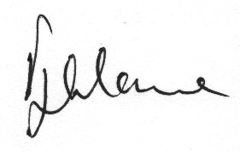

Fiona Lowe
Parish Clerk
21/09/2016

