Agenda item – 11
To consider if the Internal Auditor should be appointed for a half year audit review in November 2020 and full appointment for April 2021.

The Local Audit and Accountability Act 2014 states that:

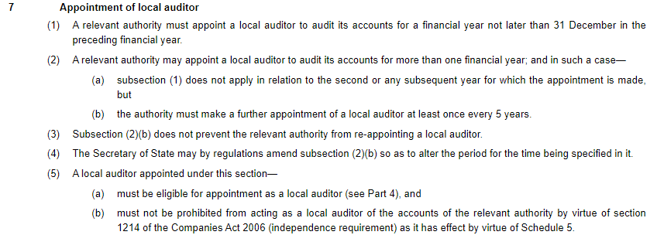

The RFO would like the Council to formally appoint an auditor to carry out a half year audit review in November in order to check:
- Accounts are being maintained properly
- Check transparency requirements are being met
- Give advice where improvement should be made (if any) prior to year end in order to ensure a clean audit report.

Additionally, Council may wish to confirm the same auditor for the final year end audit in March 2021.

