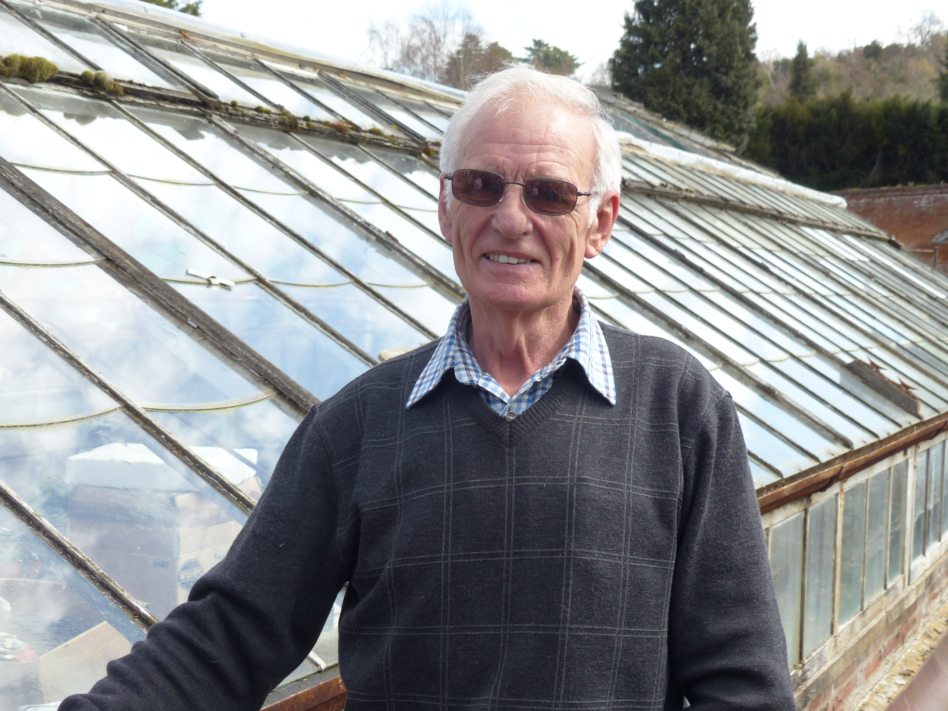
Winn John

Index number: MWOH002009

Recorded on: Wednesday 13th April 2016 by Anne Weaver and Roger Davis
Time commenced: 10.40 Duration: 33 minutes Location: Garden Cottage, Old London Rd, Mickleham.

John was born in Epsom in 1941 & came to Mickleham in 1961 to work in Mickleham Nursery. He married Yvonne in 1964 and they moved into a nearby property called The Villa. They stayed there for 5 years and then, at the suggestion of his boss, Mr Fiske, moved to Garden Cottage. John tells us that his interest in horticulture started when he took over a part of the garden at the family home in Epsom. As well as buying him a greenhouse his father bought also him a van, which he used to sell his produce, mainly bedding plants, around the area. He stresses that he had to repay his father for the van, in instalments, and that as part of the deal he had to give up smoking. His career progressed when he took a part time job at a nursery in Ewell and then at Mickleham he gained promotion to foreman. John then reflects on the changes he has seen in the running of his wholesale nursery, his inability to compete on price terms with the large retail stores, and goes on to mention some of the local stores that he used to supply. He tells us that at home nearly all the cooking is done by Yvonne, as she is a good cook, but neither of them enjoy exotic foods. Next he describes his basic life and the pleasure he gets working with nature and being self sufficient around the home. We then hear about his early days at the nursery, which was at that time much larger and was called Juniper Hill Nursery. As well as nursery plants, wheat and corn were grown, harvested and taken to the mill. He reminisces about how village life has changed, which he attributes to less people working in the village, especially on the land. John goes on to explain that he prefers to avoid using many forms of modern technology, including computers and mobile phones, finding that he manages well without. He tells us a little about his present customers, including Box Hill School, but that he has had to drop some customers as his pace has slowed with age. Although still active around the village with tasks such as judging at the Horticultural Show, winding the Church clock and cutting hedges in the memorial garden he prefers to avoid things that require set appointments. When asked he admits that he finds the pace of modern life too fast and although he likes to spend time chatting with his few local customers he finds that this is not always conducive to running a business. John & Yvonne no longer feel the need to take holidays although, in the past, they would occasionally take a week at relations near Felixstowe. We then hear about John’s only visit abroad. This was to Holland at the invitation of one of the “Dutch Boys” who would work at the nursery for 6 months each year. He describes methods of working in Holland, which he felt had advantages over his work at home, and then goes on to talk briefly about Hank at the Running Horses. Finally John explains to us the importance to him of keeping his health, and that at the moment he can’t see an end, taking each day as it comes.

