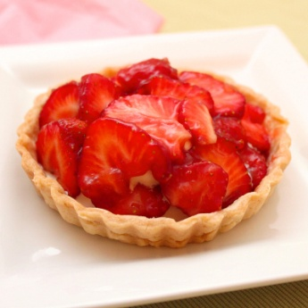

Our Diners enjoy a freshly cooked quality two course meal prepared by our professional cook.

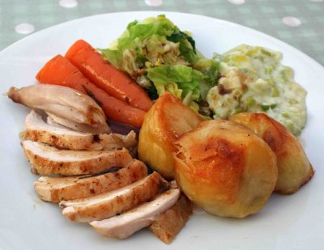

The £5.00 charge includes tea or coffee.

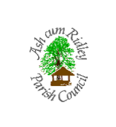

For more information, please contact the Parish Clerk on **702760** or pop into the Youth Centre on a Thursday morning.