Brockenhurst Bowling Club
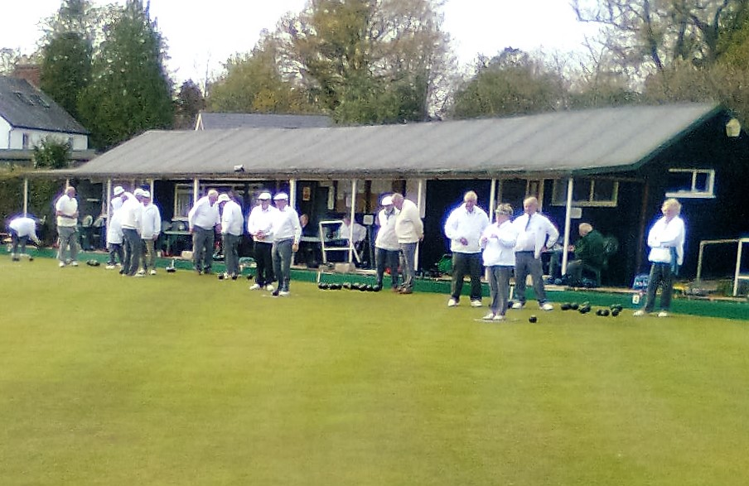
OPEN DAY
SATURDAY 21st APRIL 2018
From 10.00am until 4.00pm. Free admission, free coaching & advice.
COME ALONG AND HAVE A GO !
Flat shoes or Trainers please. Bowls provided.
Just turn up at the club in Brookley Rd Car Park and have a game and a chat.
Tele No 01425 473855

