Berwick-St-James Art Appreciation

Thursday 19th July at 7.30 (doors open 7.15)

Berwick-St-James Reading Room

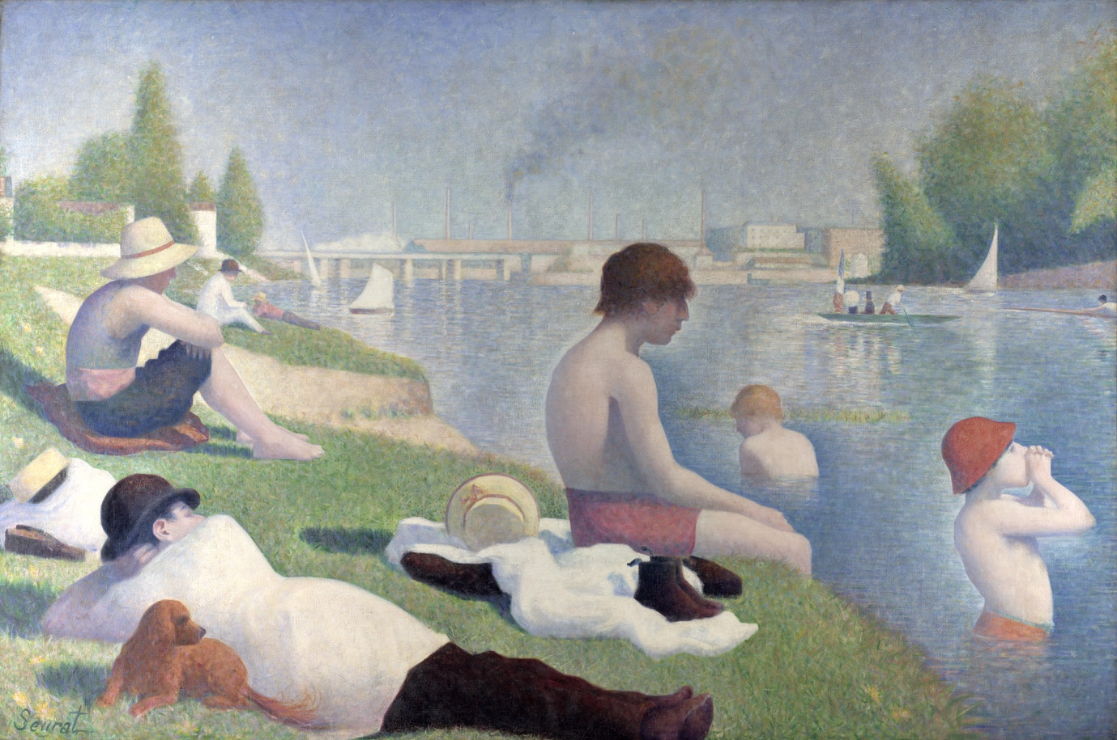
Bathers at Asnieres, 1884, Georges Seurat, National Gallery

You are cordially invited to an evening of Art Appreciation, where we will discuss together some of the best known paintings by John Singer Sargent, Pablo Picasso and Paul Matisse. We will also have a look at some of the most renowned and loved of the many treasures from across the centuries in the National Gallery and identify the features in these paintings that have entranced successive generations of art lovers. No previous knowledge required, just an enquiring mind.
Cost of admission on the door is £5/adult, to include wine, beer, or soft drinks, children under 18 free of charge, with all profits donated to the Reading Room Fund.

