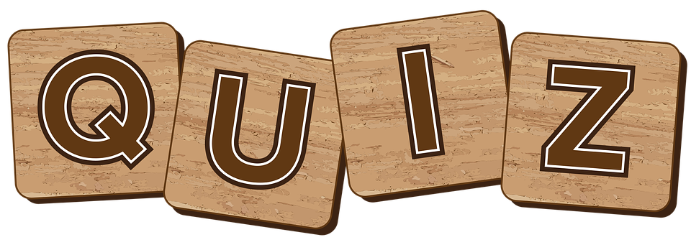
NIGHT
AT
CHELTENHAM WHADDON BOWLS CLUB
7PM
SAT 26TH NOVEMBER 2022

WE ARE LOOKING FOR 7 TEAMS OF 6 PEOPLE FOR OUR GENERAL KNOWLEDGE QUIZ.
PLEASE PUT YOUR NAMES DOWN IF YOU WOULD LIKE TO PARTICIPATE
CASH PRIZE FOR THE WINNING TEAM
ENTRY FEE £1.50 per person
BRING YOUR OWN FOOD/SNACKS
BAR AVAILABLE

CONTACT DEBBY HOOPER (info@debbyhooper.com) OR PUT YOUR NAMES ON THE SHEET IN THE BAR IF YOU WOULD LIKE TO JOIN IN THE FUN!

