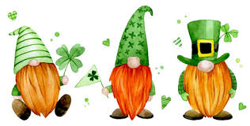
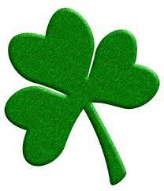 IRISH NIGHT
SATURDAY 20TH APRIL

AN EVENING OF
MUSIC FROM A LIVE BAND
IRISH FOOD
SINGING AND DANCING
AND LOTS OF FUN!
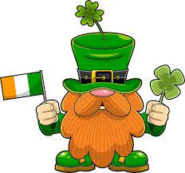 £15 PER TICKET
HOT FOOD SERVED AT 6PM - MUSIC STARTS AT 7PM
SEE DEB OR ADD NAME BELOW IF YOU WOULD LIKE A TICKET
PLEASE WEAR SOMETHING GREEN/GOLD/WHITE

