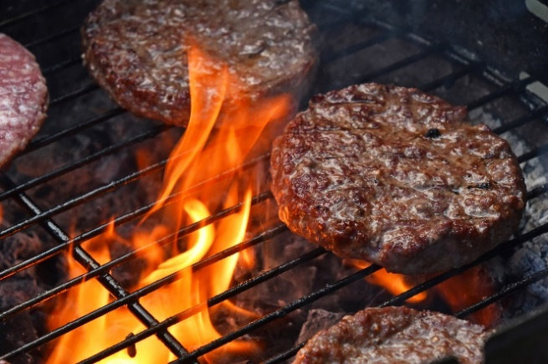

BBQ & FUN BOWLS DAY
SAT 2ND AUG 2025
12PM
FAMILIES WELCOME

BBQ FOOD SERVED THROUGHOUT THE DAY
‘ALTERNATIVE’ BOWLS GAMES
CHILDRENS RINK
*FLAT SOLED SHOES TO BE WORN ON THE GREEN

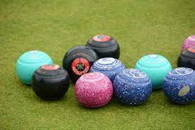
PLEASE LET DEB KNOW IF YOU WISH TO ATTEND AND HOW MANY GUESTS (FOR CATERING PURPOSES)

