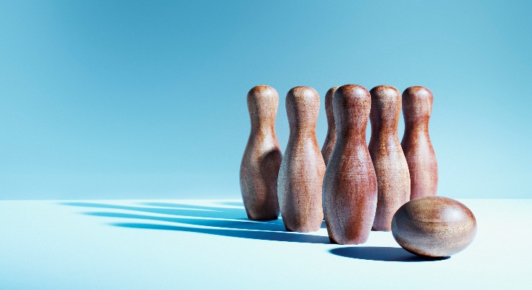

SKITTLES NIGHT

SATURDAY 15TH NOVEMBER 25
from 7pm

COME JOIN IN THE FUN!
2 GAMES OF KILLER
SAUSAGE BAPS ON SALE
BAR

Please give your name and no. of guests to Deb Hooper – (for catering purposes).

