Christmas Bingo + Fish n Chips

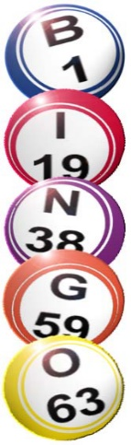

Saturday 6th December 2025
6.30pm for 7pm

£12.00 per person!!
Cash Prizes!! Raffle!!
Prize for best Christmas Jumper!
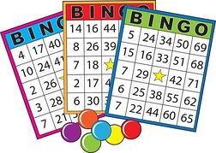

£12.00 pp Payment by cheque to Hadleigh Bowling Club Or BACS to Acc.No 18045960 Sort Code 30-13-52
Or Cash to Melanie/Clive/Carole/Steve

