Beaumont Parish Hall Committee invite you to

Family Bingo Night

at Burgh Village Hall

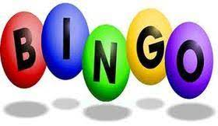

Eyes down at 6.30pm on
Saturday 21st February and Saturday 21st March

A game that the whole family can enjoy.
Beginners welcome! Come along for some fun.

Free admission

£1 per bingo book

Refreshments available Raffle

We look forward to seeing you all for a fun family evening.

All proceeds go towards Beaumont Parish Hall rebuilding fund.

