Beaumont Parish Hall Committee invite you to

Family Bingo Night

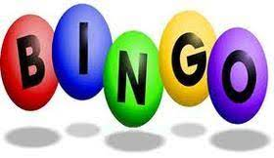

Eyes down at 6.30pm on
Saturday 18th April at Burgh Village Hall
and Saturday 16th May at Beaumont Parish Hall

A game that the whole family can enjoy.
Beginners welcome! Come along for some fun.

Free admission

£1 per bingo book

Refreshments available Raffle

We look forward to seeing you all for a fun family evening.

All proceeds go towards Beaumont Parish Hall refurbishment fund.

Next Bingo after the summer will be on
Saturday 19th September

