Coffee Morning Competition
Thursday February 26th
Who might this be, for example? 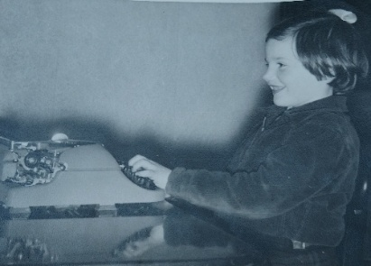

1. Find a photo of you when you were at some younger age - from babyhood upwards - and put it in an envelope along with a piece of paper with your name on it.
2. Photos must be in by Thursday February 19th at the latest.
3. To help everyone, you will be given a sticky label to make a name tag which you should wear at Coffee Morning every Thursday including competition day, February 26th.
4. The pictures will be displayed and numbered and the person who has the most correct guesses will win a prize! (You will be given a numbered sheet for your answers.)
^{GOOD LUCK and HAVE FUN.}

