Defibrillator*/CPR Training
Doddington Village Hall
Saturday March 14th 10.30 – 12.00
To book a place, please email the Parish Council Clerk, Wendy Licence at doddingtonpc@gmail.com giving a contact phone number and address.
Places are limited and will be allocated to Doddington residents on a first come, first served, basis.
* No training is actually required to use the device. It comes with its own voice instructions which are given as soon as the device is removed from its case and is opened. It won’t deliver a shock unless one is needed. This training is aimed to give users confidence.

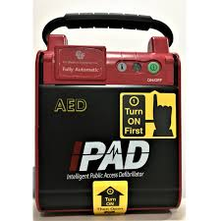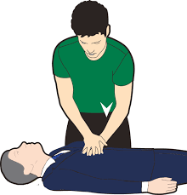

This is a free to enter event, arranged by Doddington Parish Council

