ST NICOLAS CHURCH RESTORATION GROUP
THURSDAY, 12TH MARCH 2026,
St Nicolas Church, Hail Weston PE19 5JS

An evening with:
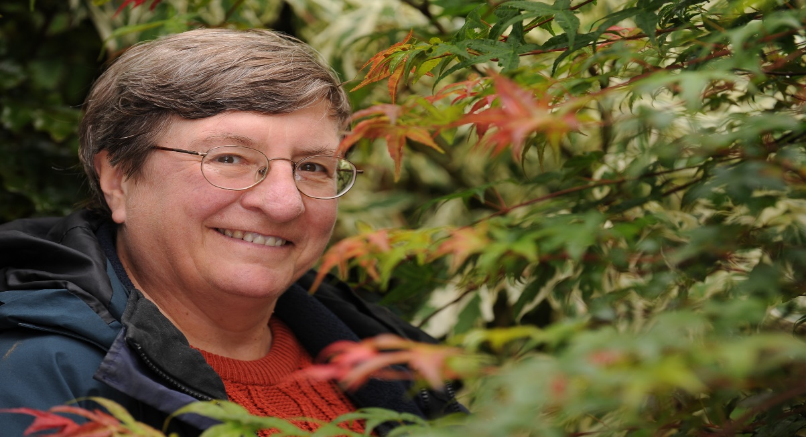
Christine Walkden
Gardener, Horticulturist, Lecturer, Adviser,
Broadcaster, Writer and Photographer
"Most Trusted Celebrity Gardener"
7 P.M. FOR 7.30 P.M.

Tickets £10.00 (including a glass of wine) available from:

Anne-Marie Hamilton – 01480 212772 annemarie@thewoodfarm.com
Veronica Bolton – 07734 824425 veronica.bolton@outlook.com

RAFFLE

