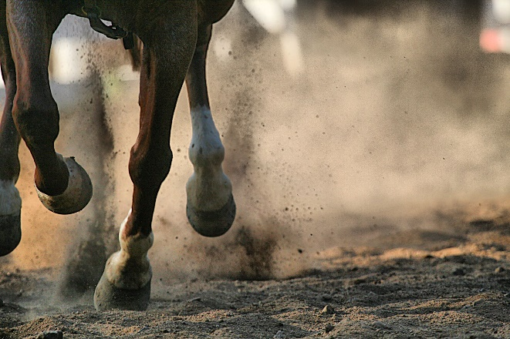

A NIGHT AT THE RACES
A FUN NIGHT OF HORSE RACING AT
CHELTENHAM WHADDON BOWLS CLUB
SAT 7TH MARCH 2026
7PM
1st RACE STARTS 7.15pm

BRING YOUR OWN FOOD/SNACKS
BAR AVAILABLE

PLEASE ADD YOUR NAME TO THE LIST BELOW IF INTERESTED

