Beaumont Parish Hall
Celebrating summer in 2026
Afternoon teas in August
Traditional homemade sandwiches and a selection of cakes with tea or coffee

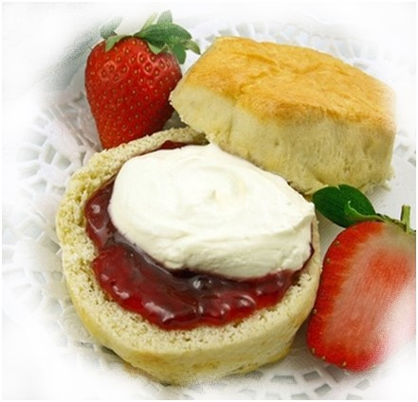
Sunday 16th, Sunday 23rd
and Sunday 30th August
2pm to 5pm

£10 per person -or why not add a little sparkle with a glass of prosecco for an extra £2?
£5 per child under 10 years of age

