Beetledrive, Sandwiches + Chips and Quiz Night
Saturday 8th August 2026
6 for 6.30pm £11 per person
Come and join us for a fun night of (not very) fiendish questions from Peter Miller, energetic Beetledrive,
good food and great company !


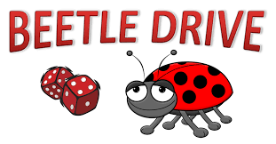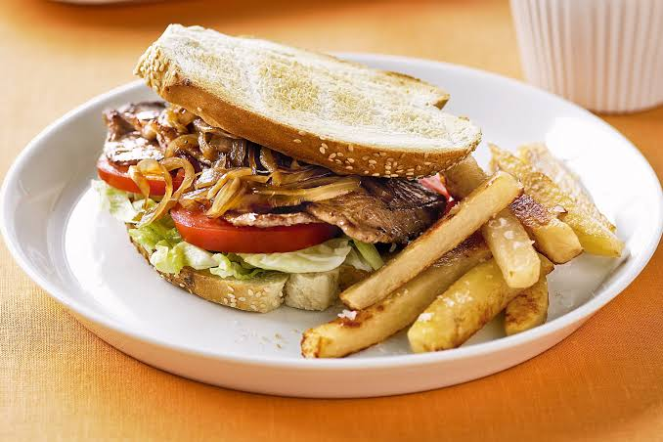
(GF is available)
The cost is £11 per person and as this event is part of the fundraising for new heating for the Club, payment is to be made through the CrowdFunder website at
https://www.crowdfunder.co.uk/p/welcome-to-hadleigh-bowls-club



