BEAUMONT PARISH HALL
Children’s Hallowe’en Party
Suitable for 11 years old and younger
On Sunday 25th October from 4 pm until 6 pm
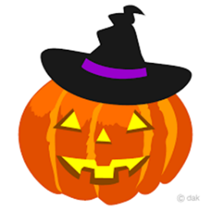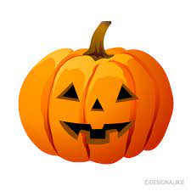
Come in your Hallowe’en costume

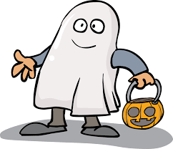
Disco and party games
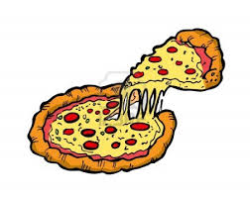 Refreshments 

£5 entry per child, refreshments included.

Book early for your child’s place.
In advance only. Limited places.

Contact Mari on 07939 635791 to book your child’s place and to discuss any dietary requirements

BACS payment to Beaumont Parish Hall
sort code:82 12 08 A/C: 00055516

