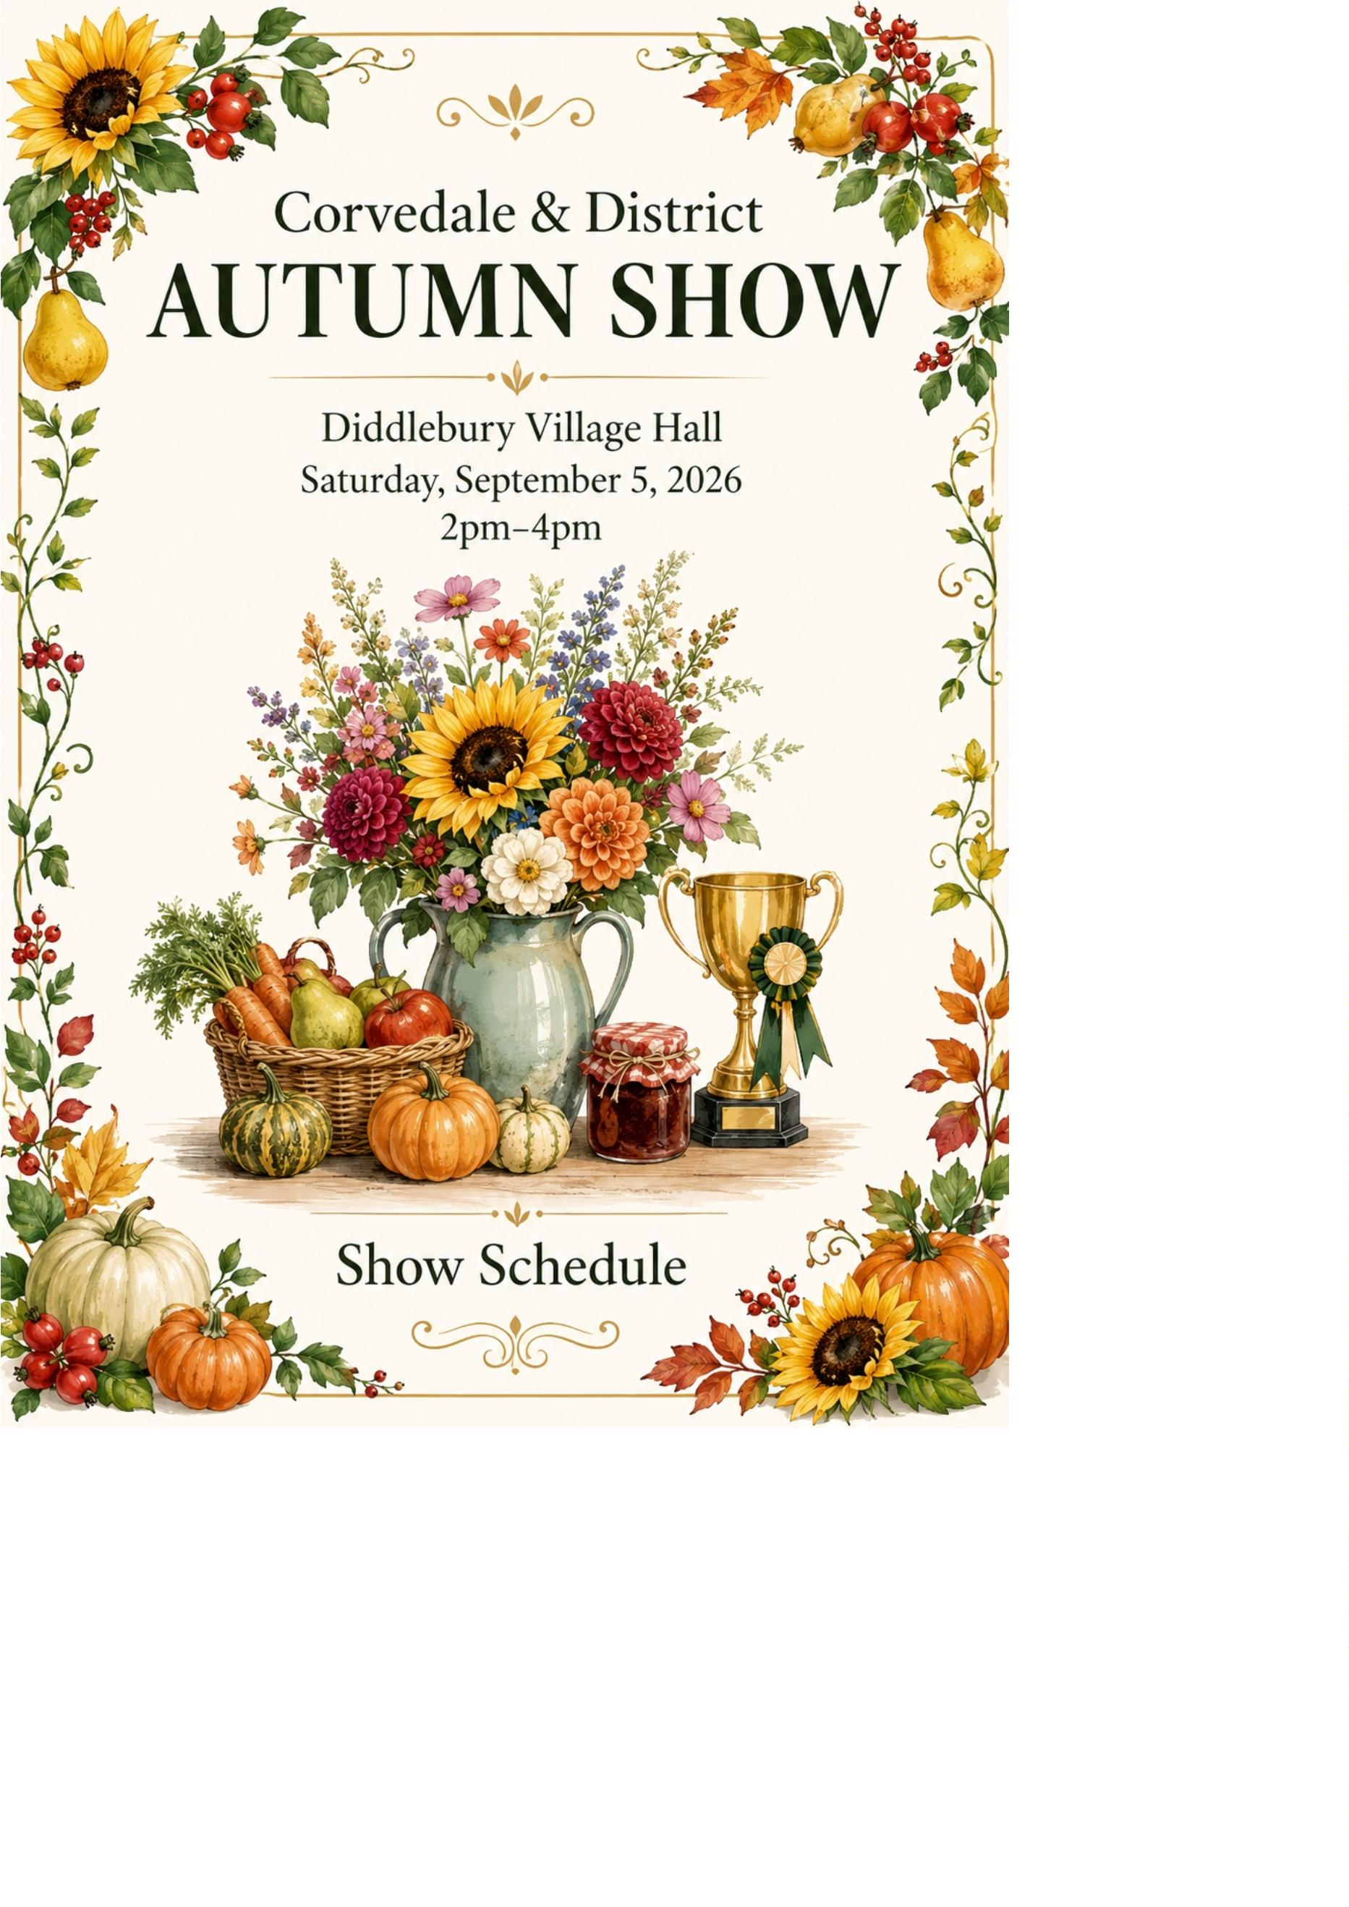

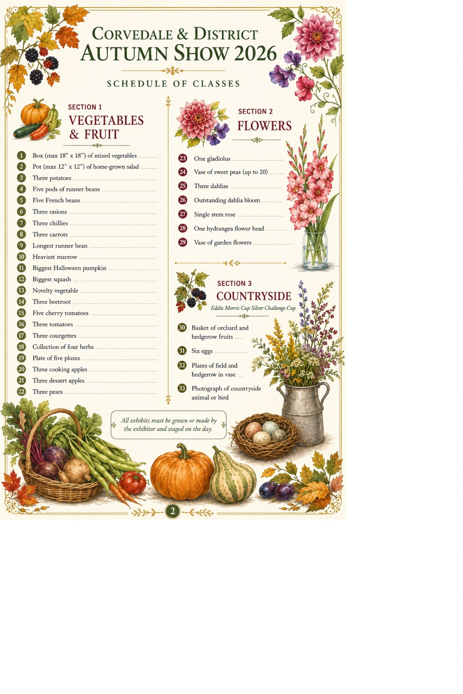

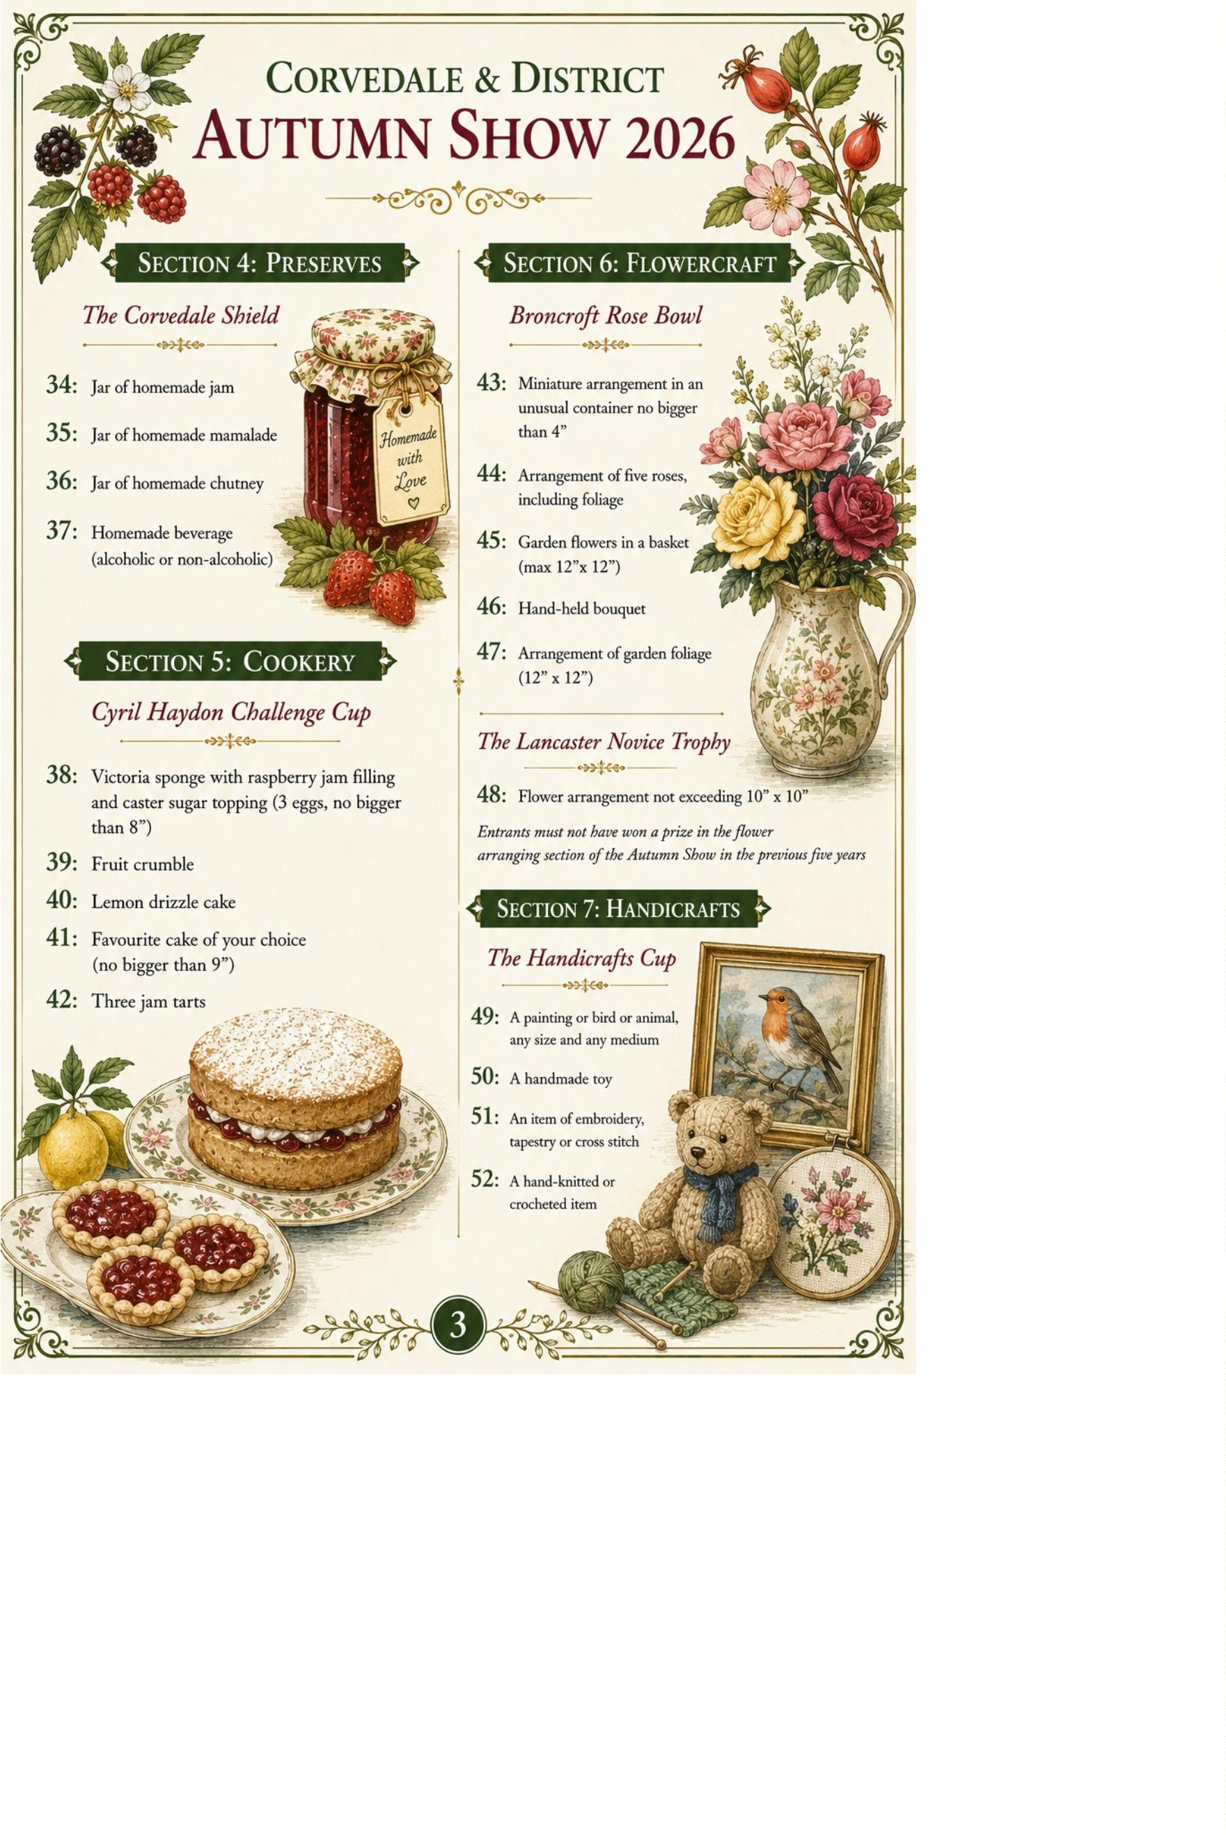

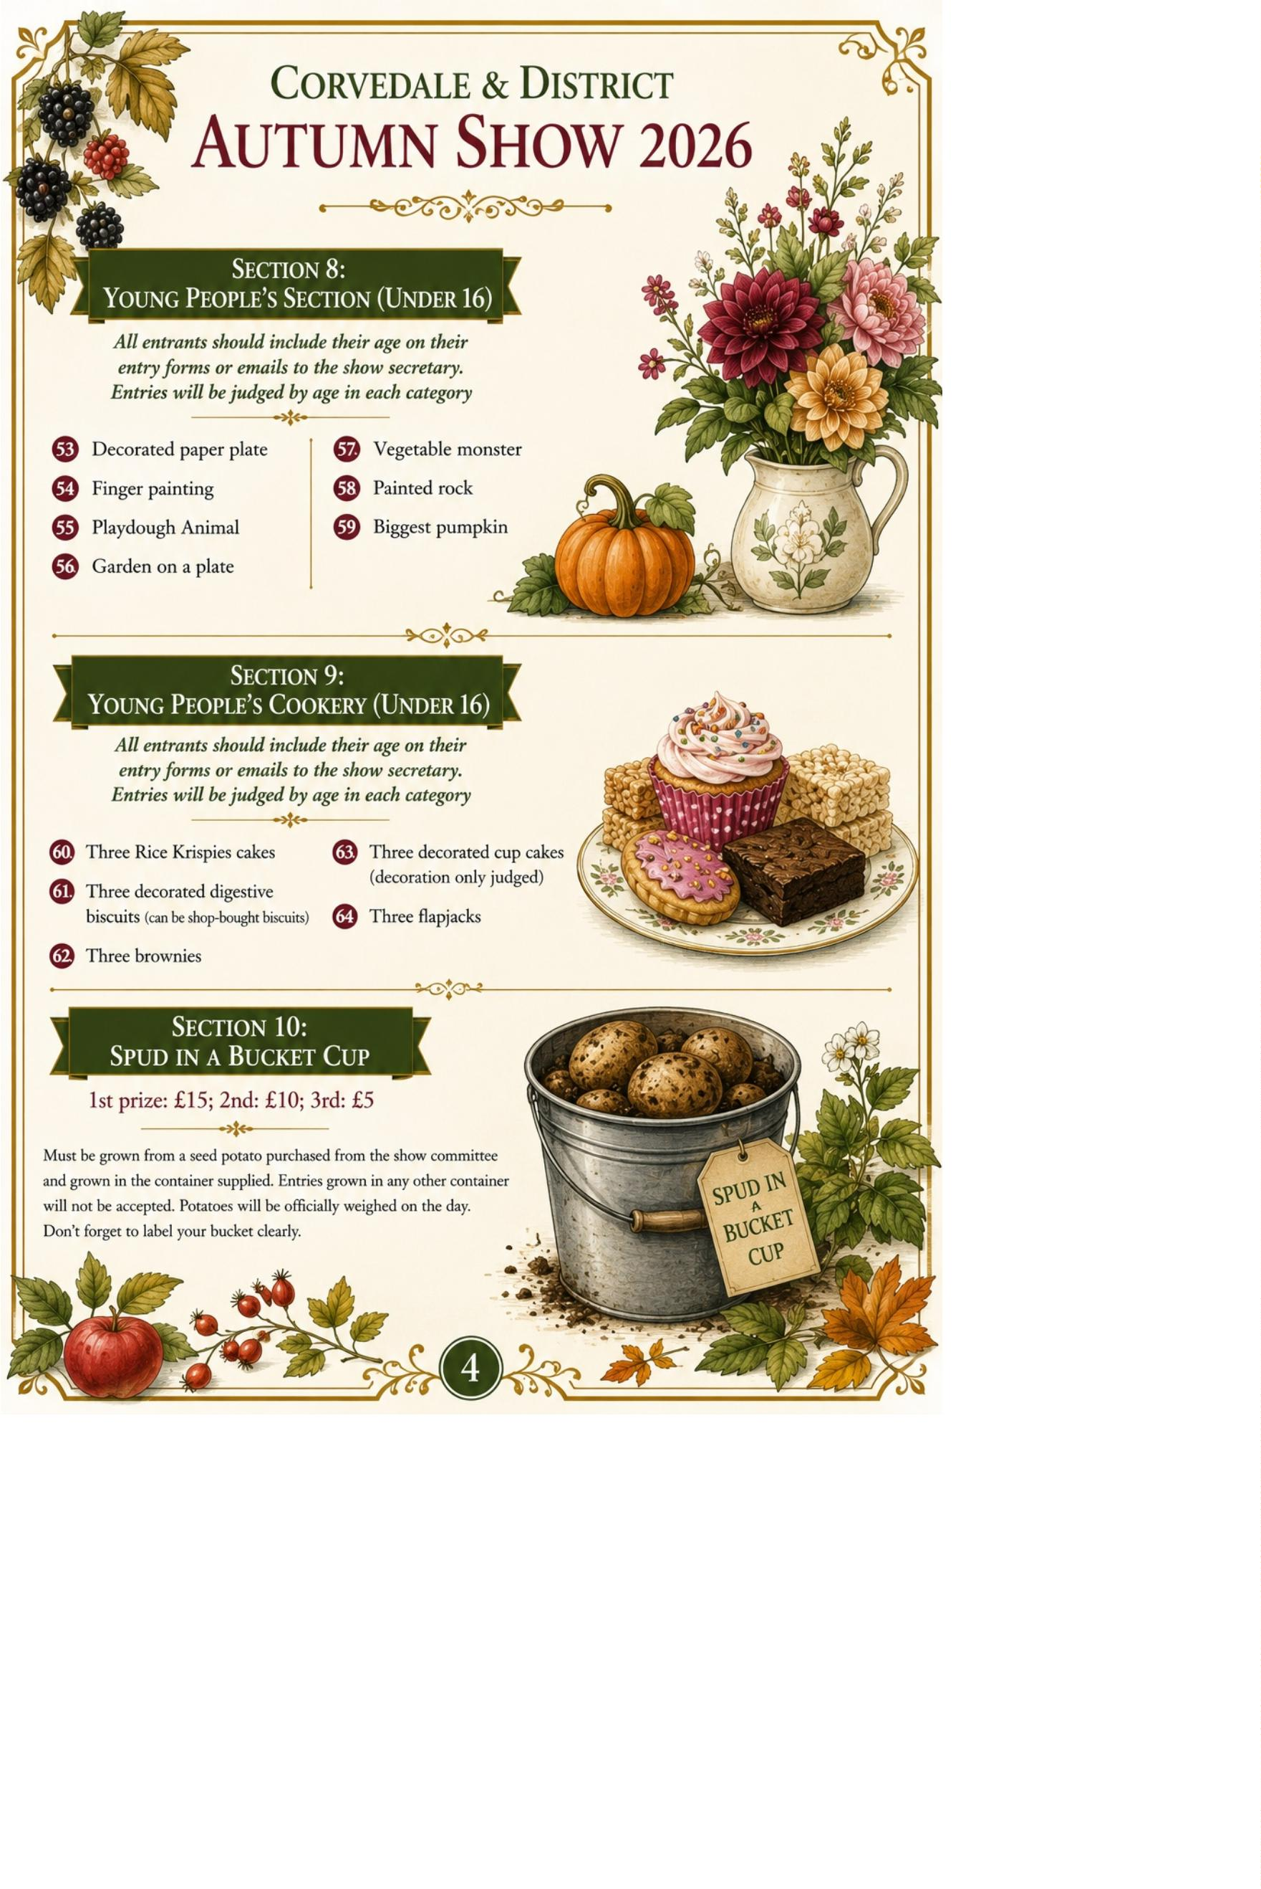

Corvedale & District Autumn Show 2026
ENTRY FORM
0
1
02
10
18
26
34
42
50
58
03
11
19
27
35
43
51
59
04
12
20
28
36
44
52
60
05
13
21
29
37
45
53
61
06
14
22
30
38
46
54
62
07
15
23
31
39
47
55
63
08
16
24
32
40
48
56
64
09
17
25
33
41
49
57
Name
__________________________________________
Address
__________________________________________
Email
__________________________________________
Telephone
__________________________________________
■
■
Please send next year's schedule by email
I wish to donate any prize money to next year's Autumn Show
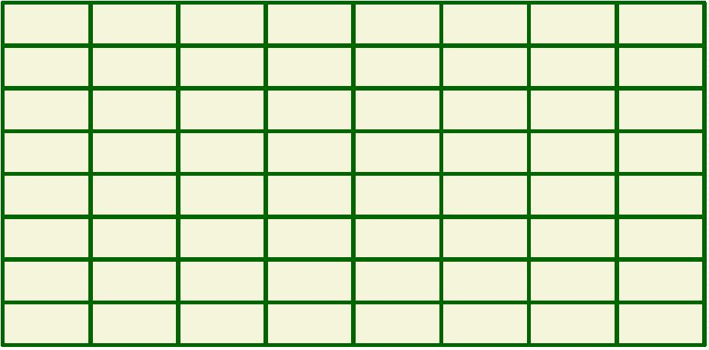

Rules for Exhibitors
1
2
3
4
5
6
7
8
9
1
1
1
. Entries must be received by Tuesday 1 September 2026.
. One exhibit per class.
. Stage exhibits Friday 7–8pm or Saturday 8.30–10.30am.
. Do not remove exhibits before prize giving.
. All exhibits must be the work of the exhibitor.
. Root vegetables with tops not exceeding 5 inches.
. Committee cannot accept responsibility for loss or damage.
. Non-compliant exhibits may be disqualified.
. Points: 1st=3, 2nd=2, 3rd=1.
0. Judges' decisions are final.
1. Cookery entries should be covered.
2. Cookery, preserves and beverages will be tasted.
Return of Trophies
Friday 21 August 2026
J. Woodhouse, 2 The Moors, Diddlebury
Entries & Enquiries
Tel: 01584 841483
Email: markandjanecockburn@btinternet.com

