Christmas Bingo + Fish n Chips

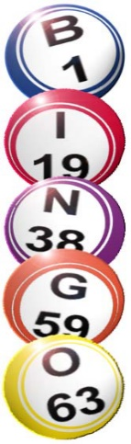

Saturday 5th December 2026
6 for 6.30 start

£12.00 per person!!
Cash Prizes!! Raffle!!
Prize for best Christmas Gear!
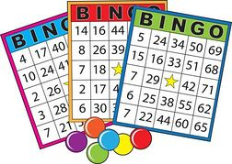

£12.00 pp Payment to Hadleigh Bowling Club
BACS to Acc.No 18045960 Sort Code 30-13-52
Or Cash to Melanie/Clive/Carole/Steve
Please pay in advance

