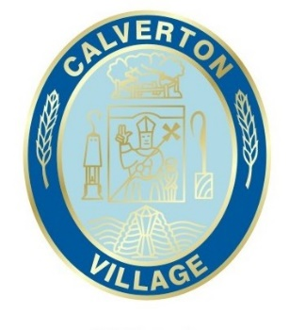
Calverton Parish council
The Council Room Main Street Calverton Nottingham NG14 6FG
Email - parishclerk@calvertonpc.org.uk
Tel. - 0115 965 4560

VACANCY
FULL TIME PARISH CLERK/RFO
The candidate must have the CiLCA qualification or be working towards it.
The Parish Clerk will manage a team of admin and ground staff to deliver services in the village, attend parish council meetings and be responsible for the parish finances.
Calverton Parish Council are responsible for two cemeteries, the upkeep of the village churchyard, a large village hall, various outdoor sporting facilities spread over two large recreation parks, two allotments, the parish office and meeting room, two public car parks and other outdoor areas.
Calverton is currently expanding at a rapid rate, and the parish council have a number of projects to start, including a large extension to the village hall, a new cemetery, and major improvements to both parks.
The post is full time, 37 hours a week and the rate of pay is in accordance with NALC pay scale point SCP 39, currently £22.65 per hour.
Benefits include membership of the generous Local Government Pension scheme and 22 paid holidays plus public holidays per year.

Please contact the Parish Council for an application form, job description and person specification at admin@calvertonpc.org.uk or on 0115 965 4560.

Closing date for applications is 4.30pm on Friday 16th September 2022.

